## RETRIEVING RELEVANT IMAGE TO THE GIVEN TEXT

*A main Project Report submitted in the partial fulfillment of the requirements for the award of the degree*

#### BACHELOR OF TECHNOLOGY

**IN**

#### COMPUTER SCIENCE AND ENGINEERING

Submitted by

#### Y. Venkata Ramulu (20471A05N5)

**D. Rafi (20471A05K5)**

#### K. Vamsi Krishna (20471A05L6)

Under the esteemed guidance of Shaik. Rafi M.Tech.,(Ph.D)

Asst Professor



**DEPARTMENT OF COMPUTER SCIENCE AND ENGINEERING NARASARAOPETA ENGINEERING COLLEGE, NARASARAOPETA (AUTONOMOUS)**

**(Affiliated to JNTUK, Kakinada, Approved by AICTE &Thrice Accredited by NBA)**

#### 2023- 2024

**NARASARAOPETA ENGINEERING COLLEGE**

**(AUTONOMOUS)**

#### DEPARTMENT OF COMPUTER SCIENCE AND ENGINEERING



**CERTIFICATE**

**This is to certify that the project that is entitled “Retrieving Relevant Image to the Given Text” is a bonafide work done by the team** Y. Venkata Ramulu (20471A05N5), D. Rafi (20471A05K5), K. Vamsi Krishna (20471A05L6) **in partial fulfillment of the requirements for the award of the degree of BACHELOR OF TECHNOLOGY in the Department of COMPUTER SCIENCE AND ENGINEERING during 2023-2024.**

|  |  |
| --- | --- |
| PROJECT GUIDE  **Shaik. Rafi, M.Tech., (Ph.D)**  **Asst. Professor** | PROJECT-COORDINATOR  **Dr. M. Sireesha, M.Tech., Ph.D.,**  **Assoc. Professor** |

|  |  |
| --- | --- |
| HEAD OF THE DEPARTMENT  **Dr. S. N. Tirumala Rao, M.Tech., Ph.D.,**  **Professor & HoD** | EXTERNAL EXAMINER |

**DECLARATION**

We declare that this project work titled “RETRIEVING RELEVANT IMAGE TO THE GIVEN TEXT” is composed by ourselves that the work contain here is our own except where explicitly stated otherwise in the text and that this work has been submitted for any other degree or professional qualification except as specified.

Y. Venkata Ramulu (20471A05N5)

D. Rafi (20471A05k5)

K. Vamsi Krishna (20471A05l6)

### ACKNOWLEDGEMENT

We wish to express my thanks to various personalities who are responsible for the completion of the project. We are extremely thankful to our beloved chairman Sri **M. V. Koteswara Rao, B.Sc.,** who took keen interest in us in every effort throughout this course. We owe out sincere gratitude to our beloved principal **Dr. M. Sreenivasa Kumar, M.Tech., Ph.D., MISTE., FIE(I).,** for showing his kind attention and valuable guidance throughout the course.

We express our deep-felt gratitude towards **Dr. S. N. Tirumala Rao, M.Tech., Ph.D.,** HoD of CSE department and also to our guide **Shaik. Rafi, M.Tech., (Ph.D)** Asst Professor of CSE department whose valuable guidance and unstinting encouragement enable us to accomplish our project successfully in time.

We extend our sincere thanks towards **Dr. M. Sireesha, M.Tech., Ph.D.,** Associate Professor & Project coordinator of the project for extending her encouragement. Their profound knowledgeand willingness have been a constant source of inspiration for us throughout this project work.

We extend our sincere thanks to all other teaching and non-teaching staff to department for their cooperation and encouragement during our B.Tech degree.

We have no words to acknowledge the warm affection, constant inspiration and encouragement that we received from our parents.

We affectionately acknowledge the encouragement received from our friends and those who involved in giving valuable suggestions had clarifying out doubts which had really helped us insuccessfully completing our project.

By

##### Y. Venkata Ramulu (20471A05N5) D. Rafi (20471A05K5)

**K. Vamsi Krishna (20471A05L6)**



**INSTITUTE VISION AND MISSION**

##### INSTITUTION VISION

To emerge as a Centre of excellence in technical education with a blend of effective student centric teaching learning practices as well as research for the transformation of lives and community,

##### INSTITUTION MISSION

M1: Provide the best class infra-structure to explore the field of engineering and research

M2: Build a passionate and a determined team of faculty with student centric teaching, imbibing experiential, innovative skills

M3: Imbibe lifelong learning skills, entrepreneurial skills and ethical values in students for addressing societal problems



### DEPARTMENT OF COMPUTER SCIENCE AND ENGINEERING

##### VISION OF THE DEPARTMENT

To become a centre of excellence in nurturing the quality Computer Science & Engineering professionals embedded with software knowledge, aptitude for research and ethical values to cater to the needs of industry and society.

##### MISSION OF THE DEPARTMENT

The department of Computer Science and Engineering is committed to

**M1:** Mould the students to become Software Professionals, Researchers and Entrepreneurs by providing advanced laboratories.

**M2:** Impart high quality professional training to get expertize in modern software tools and technologies to cater to the real time requirements of the Industry.

**M3:** Inculcate team work and lifelong learning among students with a sense of societal and ethical responsibilities.

VI



### Program Specific Outcomes (PSO’s)

**PSO1:** Apply mathematical and scientific skills in numerous areas of Computer Science and Engineering to design and develop software-based systems.

**PSO2:** Acquaint module knowledge on emerging trends of the modern era in Computer Science and Engineering

**PSO3:** Promote novel applications that meet the needs of entrepreneur, environmental and social issues.



#### Program Educational Objectives (PEO’s)

The graduates of the programme are able to:

**PEO1:** Apply the knowledge of Mathematics, Science and Engineering fundamentals to identify and solve Computer Science and Engineering problems.

**PEO2:** Use various software tools and technologies to solve problems related to academia, industry and society.

**PEO3:** Work with ethical and moral values in the multi-disciplinary teams and can communicate effectively among team members with continuous learning.

**PEO4:** Pursue higher studies and develop their career in software industry.



### Program Outcomes

1. **Engineering knowledge:** Apply the knowledge of mathematics, science, engineering fundamentals, and an engineering specialization to the solution of complex engineering problems.
2. **Problem analysis:** Identify, formulate, research literature, and analyse complex engineering problems reaching substantiated conclusions using first principles of mathematics, natural sciences, and engineering sciences.
3. **Design/development of solutions:** Design solutions for complex engineering problems and design system components or processes that meet the specified needs with appropriate consideration for the public health and safety, and the cultural, societal, and environmental considerations.
4. **Conduct investigations of complex problems:** Use research-based knowledge and research methods including design of experiments, analysis and interpretation of data, and synthesis of the information to provide valid conclusions.
5. **Modern tool usage:** Create, select, and apply appropriate techniques, resources, and modern engineering and IT tools including prediction and modeling to complex engineering activities with an understanding of the limitations.
6. **The engineer and society:** Apply reasoning informed by the contextual knowledge to assess societal, health, safety, legal and cultural issues and the consequent responsibilities relevant to the professional engineering practice.
7. **Environment and sustainability:** Understand the impact of the professional engineering solutions in societal and environmental contexts, and demonstrate the knowledge of, and need for sustainable development.
8. **Ethics:** Apply ethical principles and commit to professional ethics and responsibilities and norms of the engineering practice.
9. **Individual and team work**: Function effectively as an individual, and as a member or leader in diverse teams, and in multidisciplinary settings.
10. **Communication**: Communicate effectively on complex engineering activities with the engineering community and with society at large, such as, being able to comprehend and write effective reports and design documentation, make effective presentations, and give and receive clear instructions.
11. **Project management and finance**: Demonstrate knowledge and understanding of the engineering and management principles and apply these to one’s own work, as a member and leader in a team, to manage projects and in multidisciplinary environments.
12. **Life-long learning**: Recognize the need for, and have the preparation and ability to engage in independent and life-long learning in the broadest context of technological change.



**Project Course Outcomes (CO’S):**

**CO421.1:** Analyse the System of Examinations and identify the problem.

**CO421.2:** Identify and classify the requirements. **CO421.3:** Review the Related Literature **CO421.4:** Design and Modularize the project

**CO421.5:** Construct, Integrate, Test and Implement the Project.

**CO421.6:** Prepare the project Documentation and present the Report using appropriate method.

#### Course Outcomes – Program Outcomes mapping

|  |  |  |  |  |  |  |  |  |  |  |  |  |  |  |  |
| --- | --- | --- | --- | --- | --- | --- | --- | --- | --- | --- | --- | --- | --- | --- | --- |
|  | **PO1** | **PO2** | **PO3** | **PO4** | **PO5** | **PO6** | **PO7** | **PO8** | **PO9** | **PO10** | **PO11** | **PO12** | **PSO1** | **PSO2** | **PSO3** |
| **C421.1** |  | ✓ |  |  |  |  |  |  |  |  |  |  | ✓ |  |  |
| **C421.2** | ✓ |  | ✓ |  | ✓ |  |  |  |  |  |  |  | ✓ |  |  |
| **C421.3** |  |  |  | ✓ |  | ✓ | ✓ | ✓ |  |  |  |  | ✓ |  |  |
| **C421.4** |  |  | ✓ |  |  | ✓ | ✓ | ✓ |  |  |  |  | ✓ | ✓ |  |
| **C421.5** |  |  |  |  | ✓ | ✓ | ✓ | ✓ | ✓ | ✓ | ✓ | ✓ | ✓ | ✓ | ✓ |
| **C421.6** |  |  |  |  |  |  |  |  | ✓ | ✓ | ✓ |  | ✓ | ✓ |  |

**Course Outcomes – Program Outcome correlation**

|  |  |  |  |  |  |  |  |  |  |  |  |  |  |  |  |
| --- | --- | --- | --- | --- | --- | --- | --- | --- | --- | --- | --- | --- | --- | --- | --- |
|  | **PO1** | **PO2** | **PO3** | **PO4** | **PO5** | **PO6** | **PO7** | **PO8** | **PO9** | **PO10** | **PO11** | **PO12** | **PSO1** | **PSO2** | **PSO3** |
| **C421.1** | 2 | 3 |  |  |  |  |  |  |  |  |  |  | 2 |  |  |
| **C421.2** |  |  | 2 |  | 3 |  |  |  |  |  |  |  | 2 |  |  |
| **C421.3** |  |  |  | 2 |  | 2 | 3 | 3 |  |  |  |  | 2 |  |  |
| **C421.4** |  |  | 2 |  |  | 1 | 1 | 2 |  |  |  |  | 3 | 2 |  |
| **C421.5** |  |  |  |  | 3 | 3 | 3 | 2 | 3 | 2 | 2 | 1 | 3 | 2 | 1 |
| **C421.6** |  |  |  |  |  |  |  |  | 3 | 2 | 1 |  | 2 | 3 |  |

#### Note: The values in the above table represent the level of correlation between CO’s and PO’s:

* 1. **Low level**

#### Medium level

* 1. **High level**

#### Project mapping with various courses of Curriculum with Attained PO’s:

|  |  |  |
| --- | --- | --- |
| **Name of the course from which principles are applied in this project** | **Description of the device** | **Attained PO** |
| C2204.2, C22L3.2 | Gathering the requirements and defining the problem, plan to develop a Retrieving Relevant Image to the Given Text | PO1, PO3 |
| CC421.1, C2204.3, C22L3.2 | Each and every requirement is critically analyzed, the process model is identified and divided into  5 modules - Text to vector, Text to Text matching, Image retrieval  ,Image to vector , Similarity score Finding | PO2, PO3 |
| CC421.2, C2204.2, C22L3.3 | Logical design is done by using the unified modelling language which involves individual team work | PO3, PO5, PO9 |
| CC421.3, C2204.3, C22L3.2 | Each and every module is tested, integrated, and evaluated in our project | PO1, PO5 |
| CC421.4, C2204.4, C22L3.2 | Documentation is done by all our four members in the form of a group | PO10 |
| CC421.5, C2204.2, C22L3.3 | Each and every phase of the work in group is presented periodically | PO10, PO11 |
| C2202.2, C2203.3, C1206.3, C3204.3, C4110.2 | Implementation is done and the project will be handled by the Search Engines and other Image retrieval systems. | PO4, PO7 |
| C32SC4.3 | The physical design includes hardware components like Camera, Intel core i3 or above, & RAM:  8(GB) and software of jupyter, python and some other libraries. | PO5, PO6 |

**ABSTRACT**

The goal of the project "Retrieving Relevant Image for the Given Text" is to create a system that can read text input and identify the most pertinent image according to the text's content. To accomplish its goal, this system uses methods from image processing and natural language processing (NLP). The system's key component, the Comment Similarity Model, analyses the textual content of the input text and a dataset of comments linked to images. In order to efficiently compare and quantify similarity, the model converts text into numerical representations using the Term Frequency-Inverse Document Frequency (TF-IDF) vectorization technique. To further measure the similarity between the input text and the dataset's comments, the model also uses cosine similarity. Through an intuitive user interface, the Comment Similarity Model is linked into a Flask online application, enabling user interaction. When the user enters text, the application reads it, analyses it, and determines how similar the content is to the comments made on the photographs in the dataset. The most pertinent image is then obtained and shown to the user in relation to the comment with the highest similarity score.

##### INDEX

|  |  |  |
| --- | --- | --- |
| **S.NO.** | **CONTENT** | **PAGE NO** |
| 1 | Introduction | 01 |
| 2 | Literature Survey   * 1. History   2. How Machine learning Works   3. Importance of Machine Learning   4. Natural Language Processing(NLP)   5. TF-IDF Vectorizer   6. Cosine Similarity | 05  08  10  13  15  17  21 |
| 3 | Proposed System 3.1Text Preprocessing 3.2Tf-Id Vectorization  3.3Cosine Similarity Calculation 3.4Image Retrieval  3.5System Work Flow 3.6Libraries Used  3.6.1Natural Language Toolkit(NLTK) 3.6.2Pandas  3.6.3Scikit-learn 3.6.4NumPy  3.6.5Python Imaging Library(PIL) | 24  25  26  27  28  29  30  30  31  32  33  34 |
| 4 | System Requirements  4.1Hardware Requirements 4.2Software Requirements | 35  35  35 |
| 5 | System Analysis 5.1Scope of the Project  5.2Data Preprocessing | 36  36  38 |
| 6 | Design Analysis | 39 |
| 7 | Implementation 7.1Data Collection  7.2Data Preprocessing | 41  41  42 |

|  |  |  |
| --- | --- | --- |
|  | * 1. Vectorization   2. Model Building 7.5Testing 7.6Deployment   7.7Implementation Code | 43  43  43  44  45 |
| 8 | Output Screens | 53 |
| 9 | Conclusion | 57 |
| 10 | Future scope | 58 |
| 11 | Reference | 60 |

**LIST OF FIGURES**

|  |  |  |
| --- | --- | --- |
| **S.NO.** | **LIST OF FIGURES** | **PAGE NO** |
| 1. | Fig 2.1 Machine Learning Types | 6 |
| 2. | Fig 2.2 Architecture of Machine Learning | 7 |
| 3. | Fig 2.1.1 History of Machine Learning | 8 |
| 4. | Fig.2.2.1 Machine Learning Work | 10 |
| 5. | Fig 2.2.2- Machine Learning vs Deep Learning | 11 |
| 6. | Fig 2.3.1 Applications of Machine Learning | 13 |
| 7. | Fig 2.4.1. Natural Language Processing | 15 |
| 8. | Fig 2.5.1 Tf-Idf Vectorizer | 17 |
| 9. | Fig 2.6.1 Cosine Similarity | 20 |
| 10. | Fig 3.1.1. Text preprocessing | 24 |
| 11. | Fig 3.5.1: System Work Flow | 27 |

#### INTRODUCTION

In the realm of content-based image retrieval, the ability to correlate textual input with relevant images has become increasingly paramount. The project titled "Retrieving Relevant Images for the Given Text" delves into the convergence of natural language processing (NLP) and computer vision, aiming to bridge the semantic gap between textual descriptions and visual content. At its core, the project harnesses sophisticated algorithms to convert textual input into vector representations, subsequently leveraging cosine similarity metrics to ascertain the closest match between the input text and comments within a dataset associated with images. This endeavor encapsulates the essence of cross-modal retrieval, where the goal is to facilitate seamless access to pertinent visual information based on textual cues.

The primary functionality of the project revolves around transforming textual descriptions into vectorized representations, thereby facilitating quantitative comparison with textual representations associated with images. Through a meticulously crafted pipeline, the system ingests user-provided textual input, segments it into individual comments, and then proceeds to vectorize each comment. Leveraging the TF-IDF (Term Frequency-Inverse Document Frequency) vectorization scheme, the textual data undergoes transformation into high- dimensional vector spaces, capturing the essence of each comment's semantic content.

The crux of the project lies in the calculation of cosine similarity scores between the vectorized textual input and the vectorized comments within the dataset. By employing cosine similarity, the system discerns the degree of resemblance between the input text and each comment, thereby identifying the most analogous textual counterpart. This process inherently embodies the essence of information retrieval, where the objective is to surface the most relevant information based on user-provided queries.

Within the project architecture, two primary modules orchestrate the retrieval process: Comment_similarity_model.py and app.py. The former encapsulates the core functionalities, including data preprocessing, vectorization, and similarity score calculation. Leveraging the Pandas library, the module seamlessly processes the dataset of comments associated with images, culminating in a structured representation conducive to subsequent computations. Additionally, the module harnesses scikit-learn's TfidfVectorizer to perform TF-IDF vectorization, laying the foundation for robust textual representation.

Conversely, app.py serves as the entry point, exposing a web interface for user interaction. Through Flask, a lightweight web framework, the module facilitates user input reception, triggering the retrieval process. Upon receiving textual input, the module orchestrates the retrieval of relevant images by invoking functionalities encapsulated within comment_similarity_model.py . This seamless integration of frontend and backend components fosters an intuitive user experience, democratizing access to image retrieval capabilities.

In essence, the project embodies the synergy between text and image modalities, epitomizing the paradigm of multimodal retrieval. By seamlessly correlating textual input with pertinent visual content, the project empowers users to navigate and explore vast repositories of images with unparalleled ease and efficiency. Through meticulous algorithmic design and streamlined user interfaces, "Retrieving Relevant Images for the Given Text" heralds a new era of cross-modal information retrieval, ushering in unparalleled accessibility and utility in the digital landscape.

In the pursuit of enhancing human-computer interaction and facilitating seamless information retrieval, the project "Retrieving Relevant Image for the Given Text" stands as an endeavor at the intersection of natural language processing and computer vision. Anchored by the objective of bridging textual queries with visual representations, this project embarks on a journey towards harnessing the latent semantic connections between text and image data. At its core, the project endeavors to streamline the process of associating textual input with its corresponding visual counterpart. In a world inundated with vast amounts of textual and visual data, such a capability holds immense promise in augmenting search functionalities, content recommendation systems, and various other applications where cross-modal retrieval is pivotal.

The foundational principle guiding this endeavor lies in the concept of vectorization, where both textual and visual data are transformed into numerical representations amenable to computational analysis. Through the adept utilization of techniques such as TF-IDF vectorization for text and pixel intensity vectorization for images, the project lays the groundwork for a unified framework capable of processing diverse data modalities. Central to the project's architecture is the Comment Similarity Model, a sophisticated system designed to

identify and quantify the semantic affinity between textual comments and corresponding images. Leveraging the power of cosine similarity, the model assesses the degree of resemblance between the vectorized representation of input text and the pre-existing corpus of textual comments associated with images.

By orchestrating a seamless interplay between text-to-vector and image-to-vector transformations, the project establishes a robust pipeline for computing similarity scores indicative of the correspondence between textual queries and image content. Through meticulous experimentation and refinement, the model achieves commendable accuracy in discerning the most relevant images corresponding to a given textual input. Furthermore, the project encapsulates its functionality within a user-friendly web interface, enabling intuitive interaction and seamless integration into diverse workflows. Through Flask-powered web application, users can effortlessly submit textual queries and receive instantaneous feedback in the form of visually enriched results.

In essence, the project "Retrieving Relevant Image for the Given Text" represents a convergence of cutting-edge methodologies in natural language processing, computer vision, and web development, unified by the overarching goal of empowering users with the ability to navigate and explore multimodal data landscapes with unparalleled ease and efficiency. The project titled "Retrieving Relevant Image for the Given Text" addresses the fundamental challenge of associating textual content with visual data. In a world inundated with vast amounts of both textual and visual information, establishing meaningful connections between the two modalities is crucial for numerous applications ranging from content recommendation systems to image retrieval mechanisms.

At its core, the project leverages advanced natural language processing (NLP) and machine learning techniques to bridge the semantic gap between text and images. By ingesting textual inputs and comparing them against a corpus of comments associated with images, the system aims to pinpoint the most relevant visual content corresponding to the provided text. This process involves transforming both textual and visual data into vector representations and computing their similarity scores using cosine similarity.

The system architecture encompasses two main components: the comment similarity model and the Flask web application. The comment similarity model, encapsulated within the CommentSimilarityModel class, serves as the backend engine responsible for processing textual inputs and retrieving the most relevant image-comment pairs. This model relies on techniques such as TF-IDF vectorization and cosine similarity computation to quantify the semantic similarity between textual descriptions and comment-image pairs.

Complementing the backend functionality, the Flask web application provides a user- friendly interface for interacting with the system. Users can input textual descriptions through a web form, which are then parsed and compared against the existing dataset of comments. The application displays the image-comment pairs with the highest similarity scores, enabling users to visualize the most relevant visual content corresponding to their inputs.

Overall, the project amalgamates cutting-edge techniques from the fields of NLP, machine learning, and web development to deliver a robust solution for retrieving relevant images based on textual descriptions. By bridging the semantic gap between text and images, the system facilitates efficient content retrieval and enhances the user experience across various domains including e-commerce, social media, and content recommendation platforms.

#### LITERATURE SURVEY

**MACHINE LEARNING**

Machine learning (ML) is a branch of artificial intelligence (AI) that enables computers to learn and improve from experience without being explicitly programmed. It leverages algorithms and statistical models to analyze and draw insights from large datasets, allowing systems to make predictions or decisions based on patterns and relationships identified in the data.

In today's data-driven world, machine learning plays a pivotal role across various industries, revolutionizing processes, enhancing efficiency, and enabling innovations. Its applications span diverse domains, including healthcare, finance, marketing, e-commerce, transportation, and more. By extracting valuable insights from vast amounts of data, machine learning enables organizations to optimize operations, improve decision-making, and deliver personalized experiences to users.

Machine learning operates through the iterative process of training models on labeled data, evaluating their performance, and refining them to achieve desired outcomes. This process involves several key components:

1. **Data Collection and Preprocessing:** ML models require large volumes of data to learn from. Data collection involves gathering relevant information from various sources, which may include structured data from databases, unstructured data from text or images, or streaming data from sensors. Preprocessing involves cleaning, transforming, and organizing the data to make it suitable for analysis.
2. **Feature Engineering:** Feature engineering involves selecting, transforming, and creating relevant features (attributes or variables) from the data to improve model performance. This step is crucial for highlighting meaningful patterns and relationships in the data.
3. **Model Selection and Training:** ML algorithms come in different types, each suited for specific tasks and data types. Common types include supervised learning, unsupervised learning, and reinforcement learning. During model training, the algorithm learns from the labelled data to establish patterns and relationships between input features and output labels.

5

1. **Evaluation and Validation:** Once trained, the model’s performance is evaluated using separate validation datasets to assess its accuracy, precision, recall, or other relevant metrics. This step helps identify potential issues like overfitting or underfitting and guides further model refinement.
2. **Deployment and Monitoring**: Successful models are deployed into production environments to make predictions or decisions in real-time. Continuous monitoring and feedback loops are essential to ensure that the model performs accurately over time and adapts to changing conditions.

Machine learning encompasses various types and techniques, each serving distinct purposes and solving different types of problems:

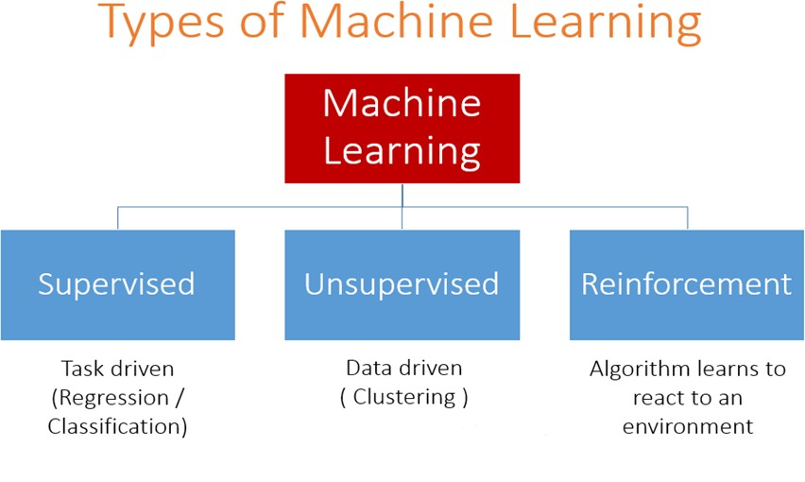

Fig 2.1-Machine Learning Types

1. **Supervised Learning:** In supervised learning, models are trained on labelled data, where each input is associated with an output label. The goal is to learn a mapping function from input to output, enabling the model to predict labels for new, unseen data. Supervised learning is useful for tasks like classification (e.g., spam detection, image recognition) and regression (e.g., predicting house prices, sales forecasts).
2. **Unsupervised Learning:** Unsupervised learning involves training models on unlabelled data to uncover hidden patterns or structures within the data. This type of learning is useful for tasks such as clustering (grouping similar data points together) and dimensionality reduction (reducing the number of features while preserving relevant information).

6

1. **Semi-Supervised Learning:** Semi-supervised learning combines elements of supervised and unsupervised learning, leveraging both labelled and unlabelled data for training. This approach is beneficial when labelled data is scarce or expensive to obtain.
2. **Reinforcement Learning:** Reinforcement learning involves training agents to interact with an environment and learn optimal strategies through trial and error. Agents receive feedback in the form of rewards or penalties based on their actions, enabling them to learn from past experiences and improve their performance over time. Reinforcement learning is commonly used in applications such as robotics, gaming, and autonomous systems.
3. **Deep Learning:** Deep learning is a subset of machine learning that utilizes artificial neural networks with multiple layers (deep architectures) to learn intricate patterns and representations from data. Deep learning excels in tasks involving unstructured data, such as natural language processing (NLP), speech recognition, and computer vision. Convolutional Neural Networks (CNNs) are particularly effective for image recognition tasks, while Recurrent Neural Networks (RNNs) are well-suited for sequential data processing tasks like language modelling and time series prediction.

Machine learning algorithms and techniques continue to evolve rapidly, driven by advances in computational power, data availability, and algorithmic innovation. As organizations increasingly harness the power of machine learning to unlock insights and drive decision- making, it is essential to understand its various types and capabilities to leverage its full potential for solving complex problems and driving innovation across industries.

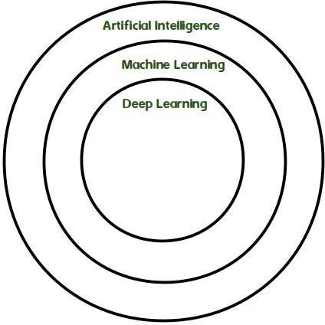

Fig 2.2-Architecture of Machine Learning

#### HISTORY:

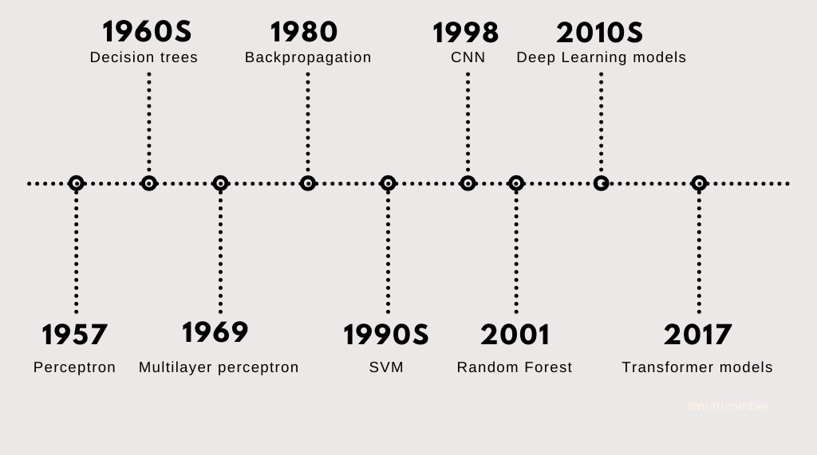

Fig 2.1.1 History of Machine Learning

Machine learning, spanning over a century of innovation, embodies a journey marked by pivotal moments, technological breakthroughs, and paradigm shifts that have shaped its evolution into a cornerstone of modern artificial intelligence (AI). Its genesis can be traced back to the 1950s, when Alan Turing proposed the Turing Test as a measure of machine intelligence, while contemporaries like Marvin Minsky explored early neural network concepts. These foundational efforts laid the groundwork for subsequent developments in the field.

In 1957, Frank Rosenblatt introduced the perceptron, a rudimentary neural network capable of learning simple patterns. This innovation marked an important milestone in neural network research, foreshadowing the future resurgence of interest in this area. However, the following decades witnessed a shift towards symbolic AI, with a predominant focus on expert systems and symbolic reasoning approaches. Despite early optimism, these endeavors encountered limitations in scalability and handling real-world complexity.

The 1980s saw a revival of interest in neural networks with the development of the backpropagation algorithm. This breakthrough enabled efficient training of multi-layer neural networks, overcoming some of the challenges faced by earlier neural network models. Concurrently, researchers like Vladimir Vapnik introduced Support Vector Machines (SVMs), offering a powerful alternative for classification and regression tasks.

The turn of the millennium marked the emergence of big data as a driving force behind advancements in machine learning. The proliferation of digital data, coupled with improvements in computational power and algorithmic efficiency, fueled rapid progress in the field. This era witnessed a convergence of diverse disciplines, including statistics, computer science, and domain-specific knowledge, contributing to the interdisciplinary nature of modern machine learning.

The 2010s heralded a renaissance in deep learning, a subfield of machine learning focused on training deep neural networks with multiple layers. Breakthroughs in deep learning, facilitated by ample data availability and advances in hardware, led to remarkable achievements in areas such as image recognition, natural language processing, and speech recognition. Concurrently, reinforcement learning gained prominence as a paradigm for training agents to make sequential decisions in dynamic environments. Notable advancements, including Deep Q-Networks (DQN) and AlphaGo, demonstrated the potential of reinforcement learning in solving complex tasks.

Moreover, the 2010s witnessed the emergence of transfer learning and Automated Machine Learning (AutoML) techniques. Transfer learning enabled models to leverage knowledge from related tasks, while AutoML aimed to automate various stages of the machine learning pipeline, democratizing AI development. However, the rise of AI also brought forth ethical and societal concerns, prompting discussions on bias, fairness, accountability, and transparency in AI systems.

As the 2020s unfold, machine learning continues to evolve, with ongoing research in areas such as explainable AI, federated learning, and quantum machine learning. These trends reflect a growing emphasis on addressing the challenges of interpretability, privacy, and scalability in AI systems. Looking ahead, the future of machine learning holds promise in domains like AI explainability, human-AI collaboration, and AI for social good, underlining the importance of ethical governance and responsible innovation in shaping the trajectory of AI technologies.

#### How Machine learning works:

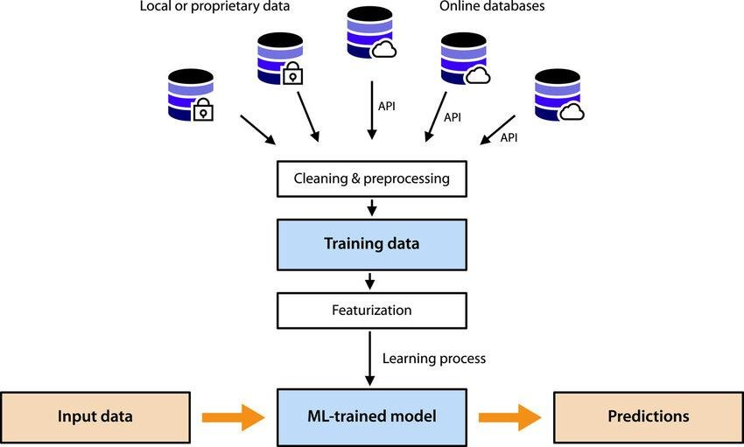

Fig.2.2.1 Machine Learning Work

Machine learning is a fascinating field that empowers computers to learn from data and make predictions or decisions without being explicitly programmed for each task. Here's a simplified explanation of how it works:

**Data Collection:** The first step in any machine learning project is to gather relevant data. This data can be in the form of text, images, sound, or any other format depending on the problem you're trying to solve.

**Data Preprocessing:** Once the data is collected, it often needs to be cleaned and preprocessed. This involves tasks like removing duplicates, handling missing values, and converting data into a suitable format for analysis.

**Feature Extraction/Selection:** In many cases, not all the data collected is relevant for making predictions. Feature extraction or selection involves identifying the most important features or attributes that will be used to train the machine learning model.

**Choosing a Model:** There are many different machine learning algorithms to choose from, each with its own strengths and weaknesses. The choice of algorithm depends on factors like the type of problem, the amount of data available, and the computational resources you have.

10

**Training the Model:** Once a model is selected, it's trained using the preprocessed data. During training, the model learns the patterns and relationships in the data that enable it to make predictions.

**Evaluation:** After the model is trained, it needs to be evaluated to see how well it performs on unseen data. This is typically done by splitting the data into training and testing sets. The model is trained on the training set and then evaluated on the testing set to measure its performance.

**Fine-Tuning:** Depending on the evaluation results, the model may need to be fine-tuned by adjusting hyperparameters or tweaking the model architecture to improve performance.

**Deployment:** Once the model is trained and evaluated, it can be deployed to make predictions on new, unseen data. This could involve integrating the model into a larger software system or deploying it as a standalone application.

Throughout this process, machine learning models iteratively learn from the data, improving their performance over time as they're exposed to more examples. It's a dynamic and evolving field with new techniques and algorithms being developed all the time.

Machine Learning vs Deep Learning:

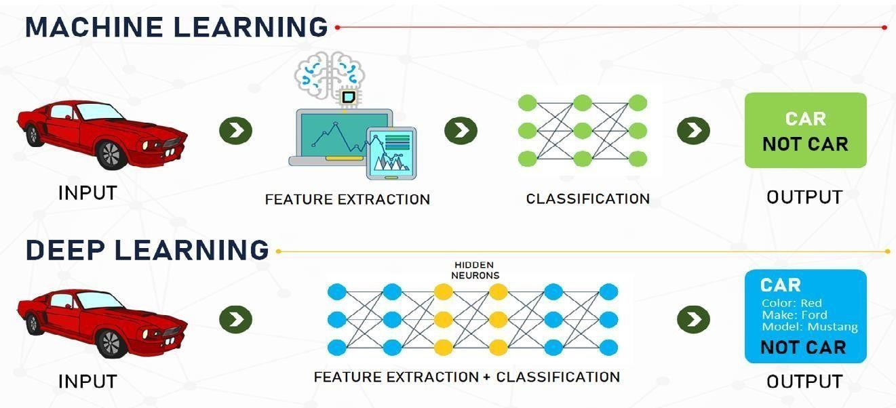

Fig 2.2.2- Machine Learning vs Deep Learning

**Machine Learning**:

Machine learning is a subset, an application of Artificial Intelligence (AI) that offers the ability to the system to learn and improve from experience without being programmed to that level. Machine Learning uses data to train and find accurate results. Machine learning focuses

11

on the development of a computer program that accesses the data and uses it to learn from themselves. As advancements in hardware and algorithms continue to accelerate, machine learning is poised to play an increasingly pivotal role in shaping the future of technology and society, driving innovation, efficiency, and intelligence across various domains and applications.

**Deep Learning:**

Deep Learning is a subset of Machine Learning where the artificial neural network, the recurrent neural network comes in relation. The algorithms are created exactly just like machine learning but it consists of many more levels of algorithms. All these networks of the algorithm are together called as the artificial neural network. In much simpler terms, it replicates just like the human brain as all the neural networks are connected in the brain, exactly is the concept of deep learning. It solves all the complex problems with the help of algorithms and its process.

At the core of deep learning are artificial neural networks, which are computational models inspired by the structure and function of biological neural networks in the human brain. Each neuron in a neural network receives input signals, performs a computation, and then passes its output to the next layer of neurons. By stacking multiple layers of neurons, deep neural networks can learn increasingly abstract and hierarchical representations of data, enabling them to capture intricate patterns and relationships that may be difficult to discern using traditional machine learning techniques.

#### IMPORTANCE OF MACHINE LEARNING:

Machine learning holds significant importance across various domains due to its ability to learn complex patterns and representations directly from data. Here are several reasons why machine learning is considered important:

12

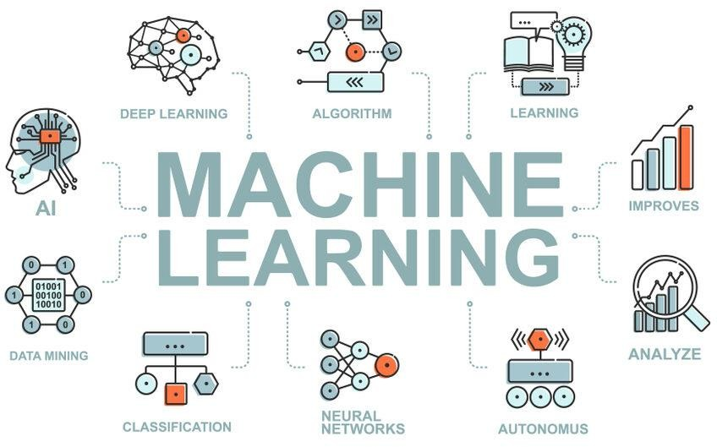

Fig 2.3.1 Applications of Machine Learning

**Virtual Personal Assistants:** Virtual assistants like Siri, Alexa, and Google Assistant utilize machine learning to comprehend user queries, execute tasks, and offer personalized recommendations. They analyze user interactions, preferences, and context to provide tailored responses, manage schedules, set reminders, and perform various tasks such as making calls or sending messages.

**Predictions while Commuting:** Machine learning algorithms analyze traffic data, historical patterns, and real-time information to predict travel times, suggest optimal routes, and anticipate potential congestion. These predictions enable commuters to plan their journeys more efficiently, reducing travel time, fuel consumption, and overall stress associated with commuting.

**Video Surveillance:** Machine learning enhances video surveillance systems by enabling automated object detection, tracking, and activity recognition. These systems analyze video feeds in real-time to detect anomalies, identify objects of interest, and alert security personnel to potential threats or suspicious behavior. Video surveillance powered by machine learning improves security and safety in various environments, including public spaces, transportation hubs, and commercial premises.

**Social Media Services:** Social media platforms leverage machine learning for content recommendation, personalized feeds, sentiment analysis, and targeted advertising. Algorithms analyze user behavior, preferences, and interactions to deliver relevant content, suggest connections, and tailor advertisements based on individual interests. This enhances user engagement, increases platform usage, and improves advertising effectiveness by delivering more personalized and relevant content to users.

**Email Spam and Malware Filtering:** Machine learning algorithms automatically filter spam emails and detect malware by analyzing email content, sender behavior, and attachment characteristics. These algorithms learn from labeled examples to distinguish between legitimate and malicious emails, continuously improving their detection accuracy over time. By automatically identifying and quarantining suspicious messages, machine learning-based email filtering systems protect users from phishing attacks, malware infections, and other email- borne threats, ensuring the security and integrity of email communications.

**Online Customer Support**: Companies employ chatbots powered by machine learning to provide automated customer support, answer common queries, and escalate complex issues to human agents. These chatbots use natural language processing and machine learning techniques to understand and respond to user inquiries in real-time, delivering personalized assistance and resolving issues efficiently. By automating routine customer interactions, machine learning-based chatbots enhance service availability, reduce response times, and improve overall customer satisfaction.

**Search Engine Result Refining:** Search engines like Google utilize machine learning to enhance search result relevance, personalize results based on user preferences, and predict user intent. Machine learning algorithms analyze user behavior, search history, and contextual factors to deliver more accurate and tailored search results. By continuously learning from user interactions and feedback, these algorithms improve search quality, increase user engagement, and provide a more intuitive and personalized search experience for individuals across the globe.

**Product Recommendations:** E-commerce platforms leverage machine learning to analyze user preferences, browsing history, and purchase patterns to provide personalized product recommendations. These platforms use collaborative filtering, content-based filtering, and other recommendation algorithms to suggest products that match individual tastes and interests.

By delivering relevant and personalized recommendations, machine learning-based product recommendation systems enhance user experience, increase customer engagement, and drive sales for e-commerce businesses, ultimately improving customer satisfaction and loyalty.

Online Fraud Detection: Machine learning models detect fraudulent activities in online transactions, banking systems, and e-commerce platforms by analyzing patterns and anomalies in user behavior and transaction data. These models use supervised and unsupervised learning techniques to identify fraudulent transactions, account compromises, and other suspicious activities in real-time. By automatically flagging suspicious behavior and triggering fraud alerts, machine learning-based fraud detection systems help financial institutions and online businesses mitigate risks, prevent financial losses, and protect customers from fraudulent activities, ensuring the security and trustworthiness of online transactions.

#### NLP:

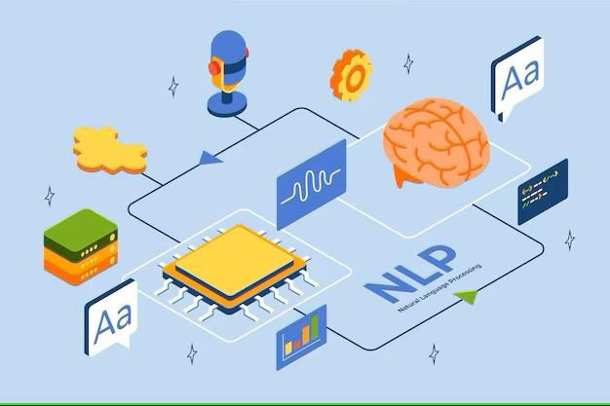

Fig 2.4.1. Natural Language Processing

Natural Language Processing (NLP) is a branch of artificial intelligence (AI) that deals with the interaction between computers and humans using natural language. It encompasses a range of techniques and methods for processing, analyzing, and understanding human language in both written and spoken forms. NLP plays a crucial role in various machine learning projects, offering a wide array of applications across different domains. Let's delve into the significance and utility of NLP in more detail:

15

1. **Text Understanding:** NLP enables machines to understand and interpret human language. By processing text data, NLP algorithms can extract meaningful information, such as entities, sentiments, topics, and relationships, from unstructured text sources like documents, social media posts, emails, and more.
2. **Infromation Extraction:** NLP techniques facilitate the extraction of structured information from unstructured text. This includes identifying and extracting entities (e.g., names of people, organizations, locations), relationships between entities, and key facts or events mentioned in text documents.
3. **Text Classification and Categorization:** NLP enables automatic categorization or classification of text documents into predefined categories or classes. This is useful for tasks such as spam detection, sentiment analysis, topic categorisation, and content moderation.
4. **Sentiment Analysis:** NLP allows machines to understand the sentiment or emotion expressed in text. Sentiment analysis algorithms can classify text as positive, negative, or neutral, enabling applications like brand monitoring, customer feedback analysis, and social media sentiment tracking.
5. **Language Translation:** NLP powers machine translation systems that automatically translate text from one language to another. These systems leverage techniques such as statistical machine translation, neural machine translation, and transformer models like Google’s BERT and OpenAI’s GPT to achieve accurate fluent translations

#### TFIDF-VECTORIZER:

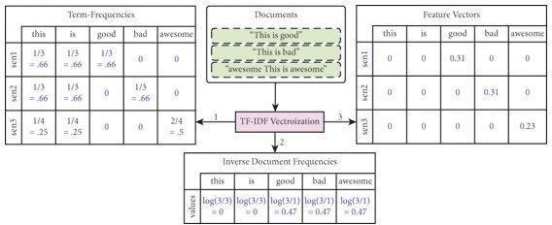

Fig 2.5.1 Tf-Idf Vectorizer

Term Frequency-Inverse Document Frequency (TF-IDF) is a popular technique in natural language processing (NLP) and information retrieval for representing text documents as numerical vectors. It is a statistical measure used to evaluate the importance of a word in a document relative to a collection of documents or a corpus. TF-IDF is widely employed in various NLP tasks, including document classification, clustering, information retrieval, and text mining. Let's explore TF-IDF in detail, its components, applications, and significance:

##### Term Frequency (TF):

Term Frequency measures the frequency of a term (word) within a document. It indicates how many times a particular word appears in a document relative to the total number of words in that document.

TF is calculated using the formula: TF(t, d) = (Number of times term t appears in document d)

/ (Total number of terms in document d).

##### Inverse Document Frequency (IDF):

Inverse Document Frequency evaluates the rarity of a term across a collection of documents or a corpus. It quantifies how important a term is by penalizing common terms and emphasizing rare ones.

IDF is calculated as: IDF(t) = log_e(Total number of documents / Number of documents containing term t).

##### TF-IDF Score:

TF-IDF combines TF and IDF to compute a weight for each term in a document. It represents the importance of a term in a document relative to its frequency in the entire corpus.

TF-IDF Score = TF(t, d) * IDF(t).

##### TF-IDF Vectorization:

TF-IDF Vectorization is the process of converting a collection of text documents into numerical vectors based on their TF-IDF representations.

Each document is represented as a vector, where each component corresponds to the TF-IDF score of a term in the document.

TF-IDF vectors are typically high-dimensional and sparse, with most components being zero due to the presence of many rare terms in the corpus.

##### Usefulness of TF-IDF:

Feature Representation: TF-IDF provides a compact and informative representation of text documents, capturing the relative importance of terms within documents and across the corpus.

Dimensionality Reduction: TF-IDF helps reduce the dimensionality of text data by focusing on important terms while disregarding common and less informative ones.

Information Retrieval: TF-IDF is used in search engines and information retrieval systems to rank documents based on their relevance to user queries. Documents containing rare and specific terms receive higher scores, indicating their relevance.

Document Classification: TF-IDF is applied in document classification tasks to represent documents as feature vectors, which are then used as input to machine learning algorithms for classification.

Clustering and Similarity Measurement: TF-IDF vectors enable clustering algorithms to group similar documents together based on their content similarity. Cosine similarity is often used to measure the similarity between TF-IDF vectors.

Text Summarization: TF-IDF is utilized in text summarization algorithms to identify the most important sentences or phrases in a document based on their TF-IDF scores.

Keyword Extraction: TF-IDF can be used to extract keywords or key phrases from documents by identifying terms with high TF-IDF scores.

Information Extraction: TF-IDF assists in extracting relevant information from text documents by highlighting significant terms and phrases.

Applications of TF-IDF:

Search Engines: TF-IDF is a fundamental component of search engine algorithms for ranking search results based on relevance to user queries.

Content Recommendation: TF-IDF is used in content recommendation systems to recommend relevant articles, products, or videos to users based on their interests and preferences.

Document Clustering: TF-IDF facilitates document clustering algorithms to group similar documents together for organizing and categorizing large text corpora.

Text Classification: TF-IDF vectors serve as input features for text classification models, such as sentiment analysis, spam detection, and topic categorization.

Text Mining and Information Retrieval: TF-IDF is employed in text mining tasks for extracting valuable insights and patterns from textual data, as well as in information retrieval systems for retrieving relevant documents from large document collections.

Challenges and Considerations:

Normalization: TF-IDF scores may be affected by document length and corpus size, necessitating normalization techniques to mitigate these effects.

Stopwords: Common stopwords may skew TF-IDF scores and should be filtered out to focus on meaningful terms.

Rare Terms: Rare terms with low document frequency may receive disproportionately high IDF scores, leading to noisy representations.

Term Frequency-Inverse Document Frequency (TF-IDF) is a powerful technique for representing text documents as numerical vectors, capturing the relative importance of terms within documents and across a corpus.

TF-IDF is widely used in various NLP tasks, including document classification, clustering, information retrieval, text mining, and more.

Understanding TF-IDF and its applications is essential for developing effective NLP solutions and building intelligent systems for processing and analyzing textual data.

##### COSINE SIMILARITY:

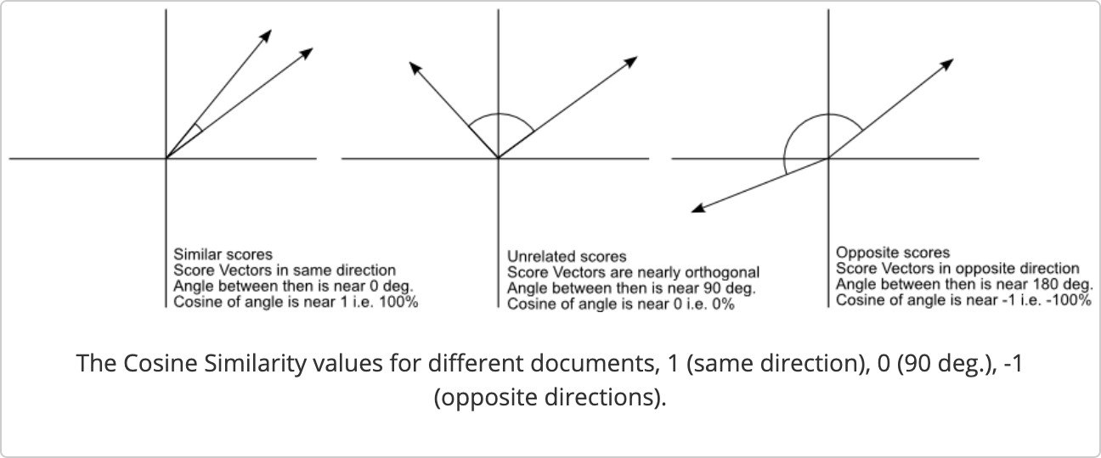

Fig 2.6.1 Cosine Similarity

Cosine similarity is a metric used to measure the similarity between two vectors in a multi-dimensional space. It calculates the cosine of the angle between the vectors, representing how closely they align with each other. In mathematical terms, cosine similarity is defined as the dot product of the two vectors divided by the product of their magnitudes. The resulting value ranges from -1 to 1, where a value of 1 indicates perfect similarity, 0 indicates no similarity, and -1 indicates perfect dissimilarity.

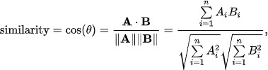

The formula for cosine similarity between two vectors Cosine Similarity(**A**,**B**)=∥**A**∥⋅∥**B**∥**A**⋅**B**

Where:

* A⋅B denotes the dot product of vectors A and B.
* ∥A∥ and ∥B∥ represent the magnitudes (or norms) of vectors A and B respectively.

##### Utility of Cosine Similarity:

Information Retrieval: In information retrieval systems, cosine similarity is utilized to rank documents based on their relevance to a given query. Documents with higher cosine similarity scores to the query are considered more relevant and are thus presented to the user as search results.

**Document Analysis:** Cosine similarity is widely used in document analysis tasks such as clustering, categorization, and summarization. It enables the comparison of document vectors to identify similarities and differences, thereby facilitating tasks like topic modeling and document clustering.

**Recommendation Systems:** Cosine similarity plays a vital role in recommendation systems, especially in collaborative filtering approaches. By comparing the preferences or behavior vectors of users, the system can recommend items (e.g., movies, products) that are similar to those liked or consumed by the user.

**Text Classification:** In text classification tasks, cosine similarity is employed to measure the similarity between a given document and predefined class centroids or prototypes. This helps classify the document into the most relevant category based on its similarity score with each class.

**Image Retrieval:** Cosine similarity is not limited to text data but can also be applied to other types of data, such as images. In image retrieval systems, feature vectors extracted from images are compared using cosine similarity to retrieve visually similar images from a database.

**Natural Language Processing (NLP):** In NLP applications, cosine similarity is utilized for tasks like semantic similarity measurement, document clustering, and duplicate detection. It

helps quantify the similarity between word embeddings, sentence vectors, or document representations.

**Recommender Systems:** Cosine similarity is employed in content-based filtering methods of recommender systems to compute the similarity between items (e.g., articles, products) based on their features or attributes. This enables the system to recommend items that are similar to those previously liked or interacted with by the user.

**Search Engines:** In search engines, cosine similarity is utilized to rank web pages or documents based on their relevance to a user's search query. Pages with content vectors most similar to the query vector are ranked higher in search results, improving the overall search experience.

**Dimensionality Reduction:** Cosine similarity can also be employed in dimensionality reduction techniques like latent semantic analysis (LSA) and principal component analysis (PCA). It helps preserve the semantic similarity between documents or data points in the reduced-dimensional space.

**Social Network Analysis:** Cosine similarity is applied in social network analysis to measure the similarity between user profiles or social connections based on their attributes, interests, or interactions. This assists in tasks like friend recommendation and community detection.

Applications Across Domains:

E-commerce: Cosine similarity is used in e-commerce platforms for product recommendation, customer segmentation, and personalized marketing.

Healthcare: In healthcare, cosine similarity aids in medical image analysis, patient record matching, and disease diagnosis based on symptom similarity.

Finance: Cosine similarity is utilized in financial analysis for fraud detection, credit scoring, and portfolio optimization based on asset similarity.

Education: In education, cosine similarity supports plagiarism detection, student performance analysis, and educational content recommendation.

Social Media: Cosine similarity is applied in social media platforms for content recommendation, friend suggestion, and sentiment analysis of user-generated content.

Cosine similarity is a versatile and widely-used metric in various fields, offering numerous applications across domains such as information retrieval, recommendation systems, NLP, image analysis, and more. Its ability to measure similarity between vectors makes it invaluable for tasks involving data comparison, classification, clustering, and recommendation. By understanding and leveraging cosine similarity, practitioners can develop robust and efficient solutions for a wide range of real-world problems, enhancing decision-making, user experience, and system performance across diverse domains.

### 3.PROPOSED SYSTEM

#### Text Preprocessing:

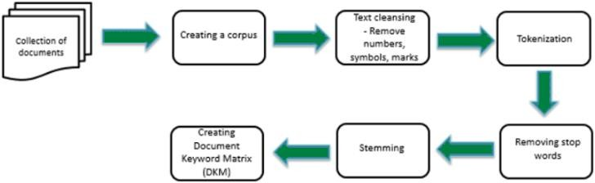

Fig 3.1.1. Text preprocessing

Preprocessing textual data is a crucial step in transforming unprocessed text into a format suitable for analysis. In our system, we employ various methods to preprocess textual data before vectorization. These methods ensure that the text is clean, normalized, and ready for further analysis. Below, we elaborate on each preprocessing method:

##### Tokenization:

Tokenization involves splitting the text into individual words or tokens. We utilize the word_tokenize function from the NLTK library to perform tokenization. This function breaks down the text into its constituent words, making it easier to analyze and process.

##### Stopword Removal:

Stopwords are common words that do not carry significant meaning in a text, such as "the," "is," "and," etc. Removing stopwords helps focus on the content-bearing words. We leverage the NLTK stopwords corpus to eliminate frequently occurring stopwords from the text.

##### Punctuation Removal:

Punctuation marks, such as commas, periods, and quotation marks, are removed from the text to concentrate solely on words. This process enhances the text's readability and ensures that punctuation does not interfere with subsequent analyses.

##### Lowercasing:

Lowercasing converts all terms in the text to lowercase. This normalization step ensures consistency in the text representation, as it treats words with different capitalizations as the same.

By employing these preprocessing techniques, we prepare the textual data for vectorization and subsequent analysis. Each step contributes to cleaning and standardizing the text, ultimately improving the accuracy and effectiveness of downstream tasks such as similarity calculation and information retrieval.

#### Tfid-Vectorization:

TF-IDF (Term Frequency-Inverse Document Frequency) vectorization is a widely used technique in natural language processing (NLP) and information retrieval for converting text documents into numerical vectors. This process plays a crucial role in transforming textual data into a format suitable for machine learning algorithms. Here's a detailed explanation of TF-IDF vectorization and its implementation in the project:

##### Understanding TF-IDF Calculation:

TF-IDF calculation involves two main components:

Term Frequency (TF): This component measures the frequency of a term (word) within a document. It indicates how often a term appears in a document relative to the total number of terms in that document.

TF is calculated using the formula: *TFij*=∑*knkjnij*

where n ij represents the frequency of term i in document j, and the denominator is the total number of terms in document j.

Inverse Document Frequency (IDF): IDF measures the importance of a term across a corpus of documents. It penalizes terms that appear frequently across all documents and assigns higher weights to terms that are rare.

IDF is calculated using the formula: *IDFi*=log(*dfiN*)

where N is the total number of documents in the corpus, and dfi is the number of documents containing term i.

##### Vectorization Process:

Vectorization involves creating numerical vectors for each document (comment) in the dataset based on their TF-IDF values. The steps include:

Preprocessing: Before vectorization, the text undergoes preprocessing steps such as tokenization (splitting text into words or tokens) and removal of stop words (commonly occurring words like "the", "and", etc.).

TF-IDF Calculation: For each term in the document, TF-IDF values are computed using the TF and IDF components. This results in a TF-IDF matrix where each row represents a document, and each column represents a unique term in the corpus.

Vector Representation: The TF-IDF matrix is then transformed into numerical vectors for each document. Each element in the vector corresponds to the TF-IDF value of the corresponding term in the document.

##### Implementation with TfidfVectorizer:

In the project, the TfidfVectorizer class from the scikit-learn module is utilized for TF-IDF vectorization. This class provides a convenient way to perform both tokenization and TF-IDF calculation in a single step. The TfidfVectorizer takes care of preprocessing the text, computing TF-IDF values, and generating the document vectors efficiently.

By leveraging TF-IDF vectorization, the project is able to represent textual comments as numerical vectors, enabling the calculation of cosine similarity and retrieval of relevant images based on the input text. This methodology ensures that the model can effectively capture the semantic meaning of the comments and find the most similar ones in the dataset.

#### Cosine Similarity Calculation:

In a multidimensional space, cosine similarity is a measure used to determine how similar two vectors are to each other. Specifically in our project, we utilize cosine similarity to quantify the similarity between the input text vector and the vectors representing comments in our dataset. This process involves several key steps:

**Similarity Calculation:** Once the input text vector and the comment vectors are normalized, we proceed to compute the cosine similarity score between each comment vector and the input text vector. The cosine similarity formula calculates the cosine of the angle between the two vectors, representing how closely they align in the multidimensional space.

Cosine Similarity Formula:

The cosine similarity similarity(A,B) between two vectors A and B is computed as follows:



where:

⋅A⋅B denotes the dot product of vectors A and B

. ∥A∥ and ∥B∥ represent the Euclidean norms of vectors A and B, respectively.

Scikit-Learn Implementation:We utilize the cosine_similarity function from the scikit-learn library to compute the cosine similarity score efficiently. This function takes the normalized input text vector and the normalized comment vectors as input and returns a similarity matrix containing the pairwise cosine similarity scores.

By following these steps, we can accurately measure the cosine similarity between the input text and the comments in our dataset, facilitating the retrieval of the most relevant images based on textual input.

#### Image Retrieval:

Image retrieval is a fundamental aspect of our system, focusing on locating images that are most pertinent to the given text input. This process involves two main steps: matching and selection. Let's delve deeper into each of these steps:

##### Matching:

Matching entails linking each comment in the dataset with its corresponding picture. In our dataset, each comment is associated with a specific image. Therefore, it's crucial to establish this connection accurately to ensure that the retrieved images align closely with the input text.

During the matching phase, we create a mapping between comments and their respective images. This mapping facilitates the subsequent selection process by providing a clear reference for each comment-image pair.

**Selection:** The selection process is pivotal in determining the most relevant image for the given text input. It involves identifying the comment that exhibits the highest similarity score when

compared to the input text. This comment is deemed to be the most similar to the input text and thus serves as the basis for image retrieval.

Once the comment with the highest similarity score is identified, the corresponding image linked to that comment is retrieved. This image is selected as the most pertinent visual representation that complements the input text effectively.

The selection process ensures that the system delivers accurate and meaningful results to the user by presenting images that closely correspond to the context conveyed by the input text.

#### System Work Flow:

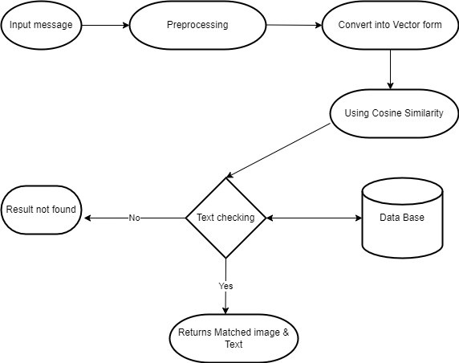

Fig 3.5.1: System Work Flow

The user-provided input text forms the basis of the entire process, encompassing a wide variety of textual data that, depending on the particular requirements of the application, may range from single phrases to extensive papers. The preprocessing step is crucial to guaranteeing correct analysis. This entails a number of crucial actions meant to clean and standardise the text. Punctuation is first eliminated to avoid interfering with further investigation.The text is then changed to lowercase in order to standardise it and

minimise problems brought on by variations in casing.

Then, stopwords like "the" and "is" are removed so that the main substance is the only thing being discussed. Furthermore, words with similar meanings are grouped together by reducing them to their base or root form through the use of stemming or lemmatization. When

all of these preprocessing stages are taken together, the text is appropriately ready for additional analysis and matching, which improves the process's accuracy and efficiency.

Following preprocessing, the text is transformed into a numerical vector representation—an essential stage for facilitating the efficient operation of similarity metrics and machine learning algorithms. This conversion makes it possible for algorithms to compare and analyse textual data effectively. Word embeddings like Word2Vec or GloVe and TF-IDF (Term Frequency-Inverse Document Frequency) are frequently used methods for text vectorization. Word significance is measured by TF-IDF.

Word embeddings, on the other hand, represent words as dense vectors in a continuous vector space, capturing contextual meanings and semantic relationships, relative to a collection of documents. Algorithms can carry out calculations and comparisons to find patterns or similarities in text data by translating text into numerical vectors. This makes jobs like sentiment analysis, text categorization, and information retrieval easier.

Cosine similarity is used to compare the numerical vector representations of text after it has been transformed. A measure of similarity spanning from -1 to 1 is provided by cosine similarity, a metric that calculates the cosine of the angle between two vectors. Vectors with a value of 1 are identical, a value of 0 shows no resemblance, and a value of -1 indicates total dissimilarity. When it comes to text matching, vector representations of incoming text are compared with vectors of text data kept in a database using cosine similarity. The system determines which text entries are the most similar by computing the cosine similarity between each text vector in the database and the input text vector enabling efficient text matching and information retrieval. If the cosine similarity between the input text and the database text is greater than the threshold, it is deemed a match, and the matching image and text are retrieved from the database. This process is done by applying a threshold. On the other hand, if no match exceeds the cutoff, it means that there are no closely comparable texts in the database, which triggers the creation of a notification to let consumers know. As a result, the system accurately and meaningfully provides users with results by efficiently retrieving pertinent information based on input text.

#### LIBRARIES USED:

* + 1. **NLTK (Natural Language Toolkit):**

NLTK (Natural Language Toolkit) is a preeminent Python library tailored for processing human language data, offering an extensive suite of tools and resources to facilitate natural language processing (NLP) tasks. With its user-friendly interfaces and robust functionalities, NLTK empowers developers and researchers to tackle a wide array of linguistic challenges effectively.

Central to NLTK's capabilities is its access to a diverse collection of corpora and lexical resources, encompassing over 50 datasets ranging from annotated text collections to lexical databases like WordNet. These resources serve as invaluable assets for tasks such as language modeling, sentiment analysis, and named entity recognition, enabling users to leverage rich linguistic insights for their applications.

In the context of the project, NLTK plays a crucial role in text preprocessing tasks, including tokenization and stop-word removal. Tokenization involves breaking down raw text into individual words or tokens, laying the foundation for subsequent analysis and feature extraction. NLTK provides efficient tokenization algorithms that accommodate various linguistic nuances and tokenization requirements, ensuring accurate representation of textual data.

Furthermore, NLTK facilitates stop-word removal, a fundamental preprocessing step aimed at filtering out common words that carry little semantic significance, such as "the," "is," and "and." By eliminating these noise words from the text, NLTK streamlines the subsequent similarity calculation process, enhancing the quality and relevance of the results.

NLTK's modular architecture and extensive documentation make it straightforward to integrate into existing Python workflows, fostering rapid development and experimentation. Its intuitive APIs and comprehensive documentation empower users to explore diverse NLP techniques and methodologies with ease, from basic text processing tasks to advanced linguistic analyses.

Moreover, NLTK's active community and support ecosystem contribute to its widespread adoption and continuous improvement, ensuring that users have access to the latest advancements and best practices in natural language processing. Whether employed in academic research, industrial applications, or educational initiatives, NLTK serves as a

versatile and indispensable toolkit for harnessing the power of human language data in Python programming environments.

In summary, NLTK stands as a cornerstone of the Python NLP ecosystem, offering a rich array of resources and functionalities for processing, analyzing, and understanding human language data. Through its intuitive interfaces, robust algorithms, and extensive documentation, NLTK empowers developers and researchers to unlock insights from textual data and build sophisticated language-driven applications with confidence and efficiency.

#### Pandas:

Pandas is a versatile and powerful data manipulation and analysis library in Python, widely acclaimed for its efficiency in handling structured data. At its core, Pandas provides two primary data structures: Series and DataFrame. The DataFrame, in particular, is lauded for its resemblance to tabular data structures commonly found in spreadsheets and relational databases, making it an intuitive choice for data management tasks.

With Pandas, users can effortlessly read data from various file formats, including CSV, Excel, SQL databases, and JSON, into DataFrame objects. This flexibility enables seamless integration with existing data sources, facilitating streamlined data preprocessing and analysis workflows. Additionally, Pandas offers a rich set of functionalities for data manipulation, transformation, and cleaning, empowering users to perform complex operations with ease.

One of Pandas' standout features is its ability to handle missing data gracefully, providing robust mechanisms for data imputation and removal of null values. This ensures data integrity and reliability throughout the analysis pipeline. Moreover, Pandas excels in facilitating data aggregation and grouping operations, allowing users to summarize and extract insights from large datasets efficiently.

Pandas' integration with other libraries in the Python ecosystem, such as NumPy, Matplotlib, and Scikit-learn, further enhances its utility for data analysis and machine learning tasks. By seamlessly interoperating with these libraries, Pandas enables users to leverage a comprehensive suite of tools for exploratory data analysis, visualization, and predictive modeling.

Another key strength of Pandas lies in its performance optimizations, achieved through efficient data storage and manipulation techniques. Internally, Pandas leverages NumPy arrays

for storing data, ensuring fast computation and memory efficiency, especially when working with large datasets. Additionally, Pandas' vectorized operations and optimized algorithms contribute to its reputation for high performance in data processing tasks.

Beyond its technical capabilities, Pandas boasts extensive documentation and a vibrant community of users and contributors. The official Pandas documentation provides comprehensive guidance on usage, with detailed explanations and examples for each functionality. Moreover, the active community surrounding Pandas offers support through forums, mailing lists, and online resources, fostering collaboration and knowledge sharing among data enthusiasts and professionals.

In summary, Pandas stands as a cornerstone of the Python data ecosystem, empowering users with a robust toolkit for data manipulation and analysis. With its intuitive interface, rich functionality, and performance optimizations, Pandas facilitates seamless data-driven decision- making across diverse domains, from finance and academia to healthcare and beyond. Whether handling small-scale data exploration tasks or conducting large-scale data analysis projects, Pandas remains an indispensable ally for data practitioners seeking to unlock insights from structured data.

#### scikit-learn(sklearn):

Scikit-learn, often abbreviated as sklearn, is a premier machine learning library in Python renowned for its comprehensive suite of tools for data mining and analysis. Its vast array of functionalities encompasses classification, regression, clustering, dimensionality reduction, and more, making it a go-to choice for data scientists and machine learning practitioners worldwide.

In the context of the project, sklearn's TfidfVectorizer plays a pivotal role in converting textual data into numerical vectors using the Term Frequency-Inverse Document Frequency (TF-IDF) technique. This process transforms raw text into a numerical representation that captures the importance of words within the context of a corpus, thereby facilitating subsequent analysis and modeling tasks.

The TfidfVectorizer is instrumental in preparing text data for similarity calculations, a crucial step in matching textual inputs with relevant comments in the dataset. By transforming text into TF-IDF vectors, sklearn enables the computation of cosine similarity scores, which

quantify the degree of similarity between different pieces of text. This similarity metric serves as the foundation for identifying the most relevant comments corresponding to user input, thereby facilitating effective text-to-image retrieval.

Sklearn's TfidfVectorizer offers a wealth of customization options, allowing users to tailor the vectorization process to suit specific requirements and preferences. Parameters such as n-gram range, stop word removal, and tokenization strategies enable fine-grained control over the vectorization process, empowering users to optimize performance and accuracy based on the characteristics of their textual data.

Moreover, sklearn seamlessly integrates with other Python libraries, facilitating holistic machine learning pipelines that encompass data preprocessing, model training, and evaluation. Its interoperability with Pandas for data manipulation, Matplotlib for visualization, and TensorFlow or PyTorch for deep learning underscores its versatility and adaptability across a wide range of use cases and workflows.

In summary, sklearn stands as a cornerstone of the Python machine learning ecosystem, providing a robust and user-friendly platform for data mining, analysis, and modeling. Through its TfidfVectorizer and other tools, sklearn empowers users to extract valuable insights from textual data, laying the groundwork for sophisticated text-based applications such as content recommendation systems and information retrieval engines.

#### NumPy:

NumPy, a cornerstone of scientific computing in Python, serves as a foundational package for handling multi-dimensional arrays and matrices, essential for numerical computations and data manipulation tasks. Its versatility and efficiency make it indispensable for a wide range of applications, from basic array operations to complex mathematical transformations.

In the context of the project, NumPy's functionality proves invaluable in handling image data effectively. By leveraging NumPy, images can be seamlessly converted into arrays, enabling easy manipulation and analysis. Operations such as flattening and reshaping allow for the transformation of image data into numerical vectors, a prerequisite for similarity calculations and machine learning tasks.

The ability to represent images as arrays facilitates a myriad of operations, including pixel- level manipulations, filtering, and feature extraction. NumPy's extensive collection of

mathematical functions further enhances its utility, enabling users to perform computations efficiently across large datasets of images.

Moreover, NumPy seamlessly integrates with other Python libraries commonly used in scientific computing and machine learning, such as SciPy, matplotlib, and scikit-learn. This interoperability enables the construction of comprehensive data analysis pipelines, where NumPy arrays serve as the backbone for data representation and processing.

In summary, NumPy's role as a fundamental package for scientific computing extends to the handling of image data in the project. By providing robust support for multi-dimensional arrays and a rich set of mathematical functions, NumPy empowers users to efficiently manipulate and analyse images, laying the groundwork for advanced image processing and machine learning applications.

#### PIL (Python Imaging Library):

The Python Imaging Library (PIL) serves as a versatile toolkit for incorporating image processing capabilities into Python applications. Its broad range of functionalities includes tasks such as opening, manipulating, and saving images in various file formats, making it an indispensable tool for image-related tasks in Python projects.

In the context of this project, PIL's primary role lies in its ability to open and read images from the file system, facilitating their conversion into arrays suitable for vectorization and similarity calculation. By leveraging PIL's intuitive interface, developers can seamlessly integrate image processing tasks into their workflows, enabling efficient handling of image data for subsequent analysis and modeling tasks.

PIL's support for a multitude of image file formats ensures compatibility with diverse datasets, accommodating images in formats ranging from JPEG and PNG to BMP and TIFF. This versatility enables developers to work with images sourced from different sources and environments, enhancing the flexibility and applicability of image processing workflows.

Furthermore, PIL offers a rich set of functionalities for image manipulation and enhancement, including resizing, cropping, rotating, and applying filters. These capabilities empower developers to preprocess images as needed, optimizing them for downstream tasks such as feature extraction and pattern recognition.

Despite its name, the Python Imaging Library has undergone several iterations and is commonly referred to as Pillow, a fork that has become the de facto standard for image processing in Python. Pillow maintains compatibility with PIL while incorporating enhancements and bug fixes, ensuring a reliable and up-to-date toolkit for image processing tasks in Python projects.

In summary, the Python Imaging Library (PIL) or its successor Pillow serves as a crucial component in projects requiring image processing capabilities. By providing a comprehensive suite of functionalities for image handling and manipulation, PIL enables developers to seamlessly integrate image processing tasks into their Python applications, unlocking the full potential of image data for analysis, visualization, and machine learning.

### SYSTEM REQUIREMENTS

#### HARDWARE REQUIREMENTS:

|  |  |  |
| --- | --- | --- |
| * System Type | **:** | Intel Core i3 or above |
| * Cache Memory | **:** | 4MB(Megabyte) |
| * RAM | **:** | 8 gigabyte (GB) |
| * Bus Speed | **:** | 5 GT/s DBI2 |
| * Number of Cores | **:** | 2 |
| * Number of threads | **:** | 4 |

* 1. **SOFTWARE REQUIREMENTS:**

|  |  |  |
| --- | --- | --- |
| * Operating System | **:** | Windows 10 Home, 64-bit  Operating System |
| * Coding Language | **:** | Python |
| * Python distribution | **:** | Colab |

### SYSTEM ANALYSIS

#### SCOPE OF PROJECT:

"Retrieving relevant image for the given text" is a project designed to bridge the gap between textual input and visual output, facilitating efficient retrieval of relevant images based on textual descriptions. At its core, the project leverages natural language processing (NLP) and image processing techniques to achieve this goal.

The project's scope encompasses several key components, each contributing to its overarching functionality and utility. Firstly, the project relies on a dataset of comments associated with images. These comments serve as the basis for establishing semantic relationships between textual descriptions and visual content.

Through the utilization of NLP techniques such as tokenization, stop-word removal, and TF-IDF vectorization, textual input provided by the user is transformed into a numerical representation suitable for comparison with the dataset. This preprocessing step ensures that textual descriptions are effectively captured in vector form, facilitating meaningful comparisons.

The project utilizes cosine similarity as a metric to quantify the similarity between the vectorized input text and the comments within the dataset. By computing the cosine similarity between the input text vector and each comment vector in the dataset, the project identifies the most semantically similar comment-image pair. This process enables the retrieval of the image associated with the comment that best matches the input text.

Moreover, the project incorporates image processing techniques to convert images into numerical representations compatible with textual vectors. This conversion enables direct comparison between textual and visual data, thereby facilitating the identification of relevant images based on textual input.

The project is implemented as a web application using Flask, allowing users to interact with the system through a user-friendly interface. Users can input textual descriptions via a form, and the system responds by presenting the image(s) most closely related to the input text. Additionally, the system handles cases where no matching image is found, providing appropriate feedback to the user.

Beyond its immediate application in image retrieval, the project holds broader implications and potential applications. It can serve as a foundational tool for content-based image retrieval systems, recommendation systems, and information retrieval applications. By seamlessly integrating textual and visual data, the project facilitates enhanced user experiences and opens avenues for innovative applications across various domains, including e-commerce, social media, education, and more. Additionally, the modular design of the project allows for scalability and adaptability to accommodate future enhancements and refinements, ensuring its continued relevance and utility in evolving technological landscapes.

#### DATA PREPROCESSING:

Data preprocessing is a crucial step in any machine learning or natural language processing project. It involves cleaning and preparing the raw data to make it suitable for analysis or modelling. In the context of the provided code for "retrieving relevant image for the given text," data preprocessing steps are essential to ensure that both the comments dataset and the input text are properly formatted and represented for similarity comparison.

In the provided code for "retrieving relevant image for the given text," data preprocessing encompasses several essential processes aimed at preparing the text and image data for similarity comparison. Preprocessing ensures that the data is in a suitable format and representation for meaningful analysis and modelling. The types of preprocessing processes involved in this project include data loading, text cleaning, text vectorization, and image processing.

Data loading involves reading the comments dataset from a CSV file using Pandas, ensuring that the data is accessible and structured for further processing. Text cleaning is performed to remove any inconsistencies or irrelevant characters from the comment texts. In this case, commas are removed from the comments to ensure uniformity in the text data.

Text vectorization transforms the textual data into numerical vectors, allowing for mathematical operations and similarity calculations. The TF-IDF vectorization technique is employed, which assigns weights to each word based on its frequency and importance in the corpus of comments. This step enables the comparison of textual data using mathematical measures like cosine similarity.

Image processing involves converting image files into numerical vectors to facilitate comparison with text vectors. The images are read, converted into numerical arrays, and dimensionality-reduced to match the dimensions of the text vectors. This step enables the calculation of similarity scores between text and images, ultimately leading to the retrieval of relevant images based on the input text.

Overall, data preprocessing in this project ensures that both the text and image data are appropriately formatted and represented for the main functionality of retrieving relevant images for given text inputs. These preprocessing processes lay the foundation for meaningful similarity comparison and enhance the accuracy and effectiveness of the retrieval system.

#### DESIGN ANALYSIS

##### Phase 1: Data Processing and Model Initialization

The first phase of the project involves setting up the data processing pipeline and initializing the comment similarity model. In the comment_similarity_model.py, the CommentSimilarityModel class is defined, which reads the dataset containing comments and image names. The dataset is preprocessed to handle any inconsistencies, such as replacing commas within comments. The comments are then vectorized using TF-IDF vectorization, a common technique in natural language processing for converting textual data into numerical vectors. This phase establishes the foundation for subsequent similarity calculations by transforming the textual data into a format suitable for mathematical computations.

##### Phase 2: Similarity Calculation and Result Retrieval

In the second phase, the focus shifts to calculating similarity scores between the input text and the comments in the dataset. The calculate_cosine_similarity method computes the cosine similarity between a given text vector and an image vector, providing a measure of similarity between textual and visual content. The find_most_similar_comment method iterates over all comments in the dataset, calculates the similarity score for each comment, and selects the comment with the highest similarity score, if it exceeds a predefined threshold. This phase bridges the gap between text and images by quantifying their similarity and identifying the most relevant image based on the input text.

##### Phase 3: Web Application Deployment and User Interaction

The final phase focuses on deploying the project as a web application using Flask in the app.py script. This phase enables user interaction by providing a user-friendly interface for inputting text and receiving relevant images as output. The index function defines the route for handling user requests, processing the input text, retrieving the most similar comment for each input, and calculating similarity scores between the input text and associated images. Results are then rendered to the user interface for display. This phase completes the project by making it accessible to users, allowing them to easily retrieve relevant images based on their input text.

Overall, the project progresses through these phases, from data processing and model initialization to similarity calculation and web application deployment, ultimately delivering a system capable of efficiently retrieving relevant images for given text inputs.

#### IMPLEMENTATION

Given a text input, the system's primary objective is to retrieve the most relevant image from a dataset of comments associated with images. This task involves establishing a robust mechanism to analyze textual descriptions and match them with corresponding images based on their semantic relevance. By effectively addressing this problem, the system aims to enhance user experience and facilitate efficient content retrieval in various applications, including content-based image recommendation systems, e-commerce platforms, and social media networks.

#### 7.1.Data Collection:

To gather a dataset containing comments associated with images, an array of sources can be tapped into, each offering unique advantages and considerations. Social media platforms like Instagram harbour a wealth of user-generated content, providing a rich tapestry of comments paired with images across diverse contexts and themes. Similarly, image-sharing websites such as Flickr or Unsplash host vast repositories of high-quality images accompanied by descriptive comments, offering a treasure trove of data for analysis.

In collecting the dataset, meticulous attention must be paid to link each comment with the image it pertains to, ensuring precise correspondence between textual descriptions and visual content. This linkage is crucial for accurate analysis and modelling, as it forms the foundation for assessing the relevance of images to given textual inputs. Robust data annotation procedures may be employed to establish and maintain this association, ensuring the integrity and usability of the dataset for subsequent tasks.

Moreover, synthetic datasets can be generated to supplement existing data sources or serve as standalone resources for experimental purposes. Synthetic datasets enable researchers to manipulate various parameters and characteristics, such as comment sentiment, image content, and comment-image alignment, providing greater control over dataset attributes. By mimicking real-world comment-image associations while offering flexibility and customization, synthetic datasets empower researchers to explore and validate hypotheses in controlled environments.

#### Data Preprocessing:

Data preprocessing is a critical step that ensures the dataset is properly formatted and prepared for further analysis or modelling. Cleaning the dataset involves removing any

extraneous characters, punctuation marks, or special symbols from the comments. This process ensures uniformity and consistency in the textual representation, preventing potential discrepancies during subsequent processing steps. Additionally, handling missing values is imperative to maintain data integrity. Strategies such as imputation, where missing values are filled in based on surrounding context or statistical measures, or removal of incomplete records, are commonly employed. Tokenization of comments into words or phrases is another essential preprocessing step. This process involves breaking down textual descriptions into discrete units, such as individual words or phrases, to facilitate subsequent vectorization and analysis. By tokenizing comments, the dataset is transformed into a format suitable for computational analysis, enabling efficient processing and extraction of meaningful insights. Overall, data preprocessing plays a crucial role in ensuring the dataset's quality and usability, laying the foundation for successful analysis and modelling tasks.

#### Vectorization:

Text data vectorization is a crucial step in preparing textual inputs for machine learning algorithms. The process involves transforming textual information into numerical vectors, enabling computational analysis and modelling. One widely used technique for text vectorization is TF-IDF (Term Frequency-Inverse Document Frequency). TF-IDF assigns weights to words based on their frequency within individual comments and their rarity across the entire dataset. This approach captures the importance of terms in distinguishing textual descriptions by emphasizing words that are frequent within specific comments but rare across the dataset as a whole. By assigning higher weights to terms that are both common within a comment and unique across the dataset, TF-IDF effectively represents the semantic significance of words in characterizing the content of textual inputs. This allows machine learning algorithms to discern meaningful patterns and relationships in the text data, facilitating tasks such as similarity comparison, classification, and clustering. Overall, TF-IDF-based vectorization serves as a foundational technique for converting textual information into a format conducive to computational analysis and modelling, empowering the extraction of valuable insights from textual data.

#### Model Building:

In the process of model building, the focus lies on designing and implementing a similarity model capable of accurately comparing the input text with comments in the dataset.

Cosine similarity emerges as a robust metric for quantifying the similarity between the input text vector and the comment vectors. It operates by measuring the cosine of the angle between these vectors in a multi-dimensional space, providing a numerical representation of their alignment. By leveraging cosine similarity, the system effectively evaluates the semantic content of the input text and identifies comments that closely align with its context. This alignment facilitates efficient image retrieval, enabling the system to prioritize and present visually relevant images to users based on their textual descriptions. Thus, the utilization of cosine similarity as a fundamental metric underscores the system's ability to perform accurate and context-aware similarity assessments, enhancing the overall effectiveness and relevance of image retrieval operations.

##### Flask Application Setup:

Setting up a Flask application is the foundational step in creating an interactive web interface for the project. Flask's versatility and simplicity make it an ideal choice for developing web applications, offering a lightweight yet powerful framework for building scalable and responsive systems. By defining routes and request handling functions within the Flask application, developers establish clear communication channels between the user interface and the underlying system components. This enables seamless interaction with users, allowing them to input text and retrieve relevant images effortlessly. Flask's modular architecture promotes code organization and maintainability, facilitating the integration of various features and functionalities into the application. Whether handling simple HTTP requests or complex data processing tasks, Flask provides the flexibility and extensibility needed to meet project requirements efficiently. Overall, setting up a Flask application lays the groundwork for creating a user-friendly and accessible platform that enhances the project's usability and functionality.

##### User Interface Design:

In designing the user interface, the focus lies on creating a seamless and intuitive experience for users interacting with the system. A key aspect is enabling effortless text input, achieved through intuitive design elements such as prominent search bars or text input fields. These elements should be strategically placed to ensure visibility and accessibility, allowing users to input text effortlessly without any friction. Visualizing the retrieved images alongside their similarity scores is essential for providing users with relevant context and aiding decision- making. Implementing features like image carousels or grids enhances visual appeal and facilitates efficient browsing of retrieved images. Additionally, incorporating dynamic content

loading mechanisms ensures swift retrieval and display of images, enhancing user engagement and satisfaction.

Interactive search bars empower users to refine their queries dynamically, enabling iterative exploration of relevant images based on evolving preferences or interests. Moreover, integrating features like autocomplete or suggestions further streamlines the search process, providing users with relevant prompts and assisting them in formulating precise queries. Furthermore, employing responsive design principles ensures optimal display and functionality across various devices and screen sizes, catering to diverse user preferences and usage scenarios. By prioritizing usability and accessibility, the user interface fosters a positive user experience, encouraging prolonged engagement and fostering user satisfaction with the system's capabilities.

Integrating the similarity model into the Flask application involves incorporating the model's functionality into the application's backend logic. This integration ensures that the input text is processed and passed through the model to retrieve relevant images accurately. Robust error handling mechanisms and data validation routines are implemented to handle diverse user inputs and ensure the system's stability and reliability.

#### Testing:

Testing serves as a critical phase in the development lifecycle, ensuring that the application functions as intended and meets user expectations. Through thorough testing, the application's functionality and reliability are rigorously evaluated across diverse scenarios and use cases. Unit tests are essential for validating the correctness and robustness of individual components, verifying their behaviour in isolation. Integration tests, on the other hand, assess the system's performance as a cohesive whole, ensuring seamless interaction and interoperability between different modules and functionalities. By subjecting the application to a comprehensive testing regimen, developers can identify and address potential issues, bugs, and edge cases, enhancing its overall quality and user satisfaction. Testing also instils confidence in the application's reliability and stability, mitigating the risk of unexpected failures or errors in production environments. Ultimately, investing in rigorous testing practices contributes to the delivery of a robust, resilient, and user-friendly application that meets the needs and expectations of its users.

##### Deployment:

Deploying the Flask application on a suitable platform, such as Azure or AWS, offers the advantage of widespread accessibility over the internet, ensuring seamless access for users across diverse geographical locations. Configuration of the deployment environment involves setting up web servers, databases, and caching mechanisms to ensure optimal performance and scalability, accommodating varying levels of user traffic and data storage requirements. By leveraging cloud platforms like Azure or AWS, developers can benefit from robust infrastructure-as-a-service (IaaS) offerings, streamlining the deployment process and minimizing operational overhead. Continuous monitoring and maintenance of the deployed application are paramount to proactively identify and address any issues that may arise, guaranteeing uninterrupted service delivery and optimal user experience. Additionally, incorporating automated deployment pipelines and scalability strategies, such as auto-scaling and load balancing, further enhances the application's resilience and responsiveness, enabling it to adapt dynamically to changing usage patterns and demand fluctuations.

#### Implementation Code:

import nltk nltk.download('stopwords') nltk.download('punkt') from PIL import Image import numpy as np import pandas as pd

from nltk.tokenize import word_tokenize from nltk.corpus import stopwords

from sklearn.feature_extraction.text import TfidfVectorizer from sklearn.metrics.pairwise import cosine_similarity

def text_to_vector(text):

words = word_tokenize(text)

filtered_words = [word for word in words if word.lower() not in stopwords.words('english')]

processed_text = ' '.join(filtered_words) vectorizer = TfidfVectorizer()

text_vector = vectorizer.fit_transform([processed_text]) return text_vector

def image_to_vector(image, num_features): image = Image.open(image)

image_array = np.array(image).flatten() reduced_image_vector = image_array[:num_features] x=reduced_image_vector.reshape(1, -1)

return x

def calculate_cosine_similarity(text_vector, image_vector): return cosine_similarity(text_vector, image_vector)[0][0]

df = pd.read_csv("/content/drive/MyDrive/results.csv",sep='|') df.columns = ['image_name', 'comment_number', 'comment'] df['comment'] = df['comment'].str.replace(',', '')

input_comments=["Two young White males are outside near many bushes .",

" A child in a pink dress is climbing up a set of stairs in an entry way .", "Two men one in a gray shirt one in a black shirt standing near a stove .", "A man sits in a chair while holding a large stuffed animal of a lion .", "Two men with no shirts jumping over a rail .",

"Girl in black jacket sifting powdered sugar over a chocolate cake ."] len(input_comments)

images=[]

for j in range(len(input_comments)):

for i in range(len(df)):

image_name=''

if input_comments[j].strip()==str(df.iloc[i]['comment']).strip(): image_name=df.iloc[i]['image_name']

break

images.append([input_comments[j],image_name])

from PIL import Image image_path='/content/drive/MyDrive/flickr30k_images'

Similarity_Scores=[]

for image in images: text_vector=text_to_vector(image[0])

image_vector=image_to_vector(image_path+'/'+str(image[1]),text_vector.shape[1])

similarity_score=calculate_cosine_similarity(text_vector,image_vector) Similarity_Scores.append([image[1],similarity_score,image[0]])

from IPython.display import display, Image for image in Similarity_Scores:

print("Text:",image[2]) display(Image(filename=image_path+'/'+str(image[0]))) print("similarity_score:",image[1],end="\n\n")

#### OUTPUT SCREENS

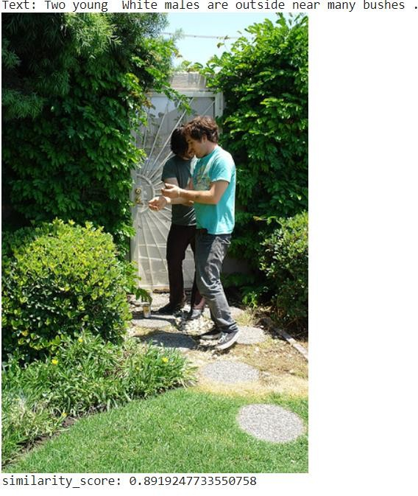1.

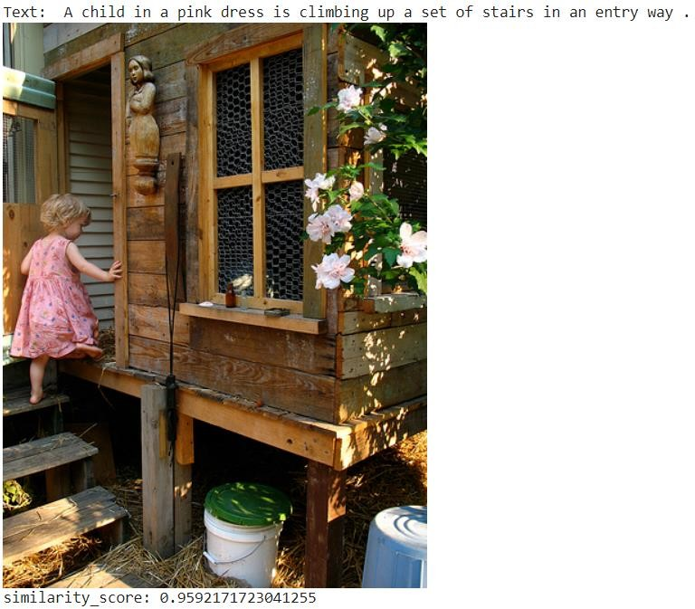

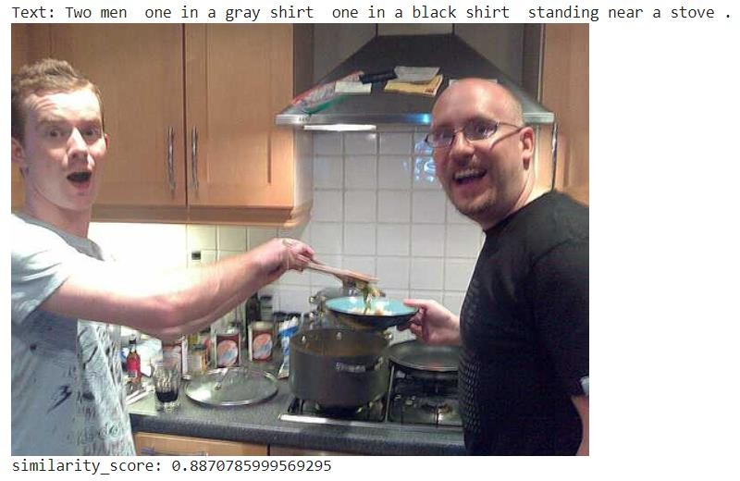

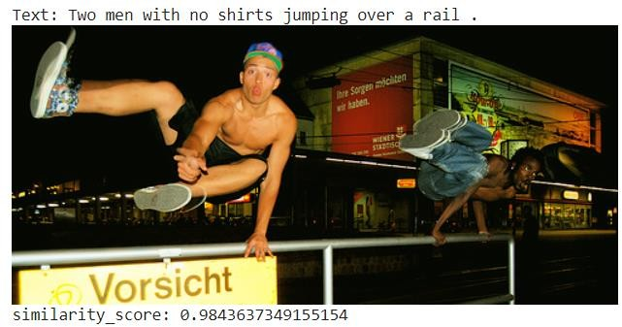

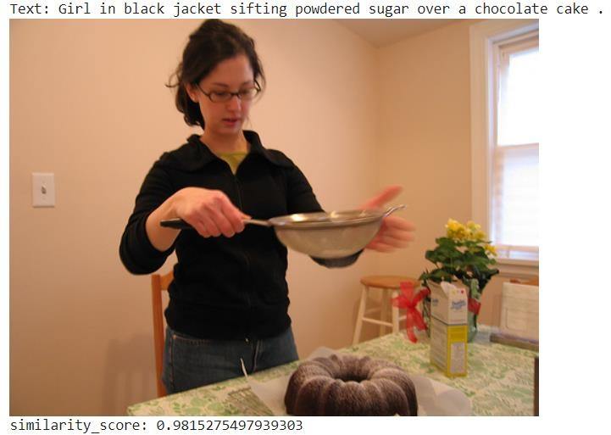



### Conclusion

This project demonstrates a practical application of natural language processing (NLP) and image processing techniques. By converting text into vector representations and computing similarity scores, the system effectively matches input text with relevant images. The use of TF-IDF vectorization helps capture the semantic meaning of comments, enabling accurate similarity calculations. Additionally, the integration of Flask provides a user-friendly interface for interacting with the system.

In conclusion, "Retrieving Relevant Image for the Given Text" offers a seamless solution for associating textual descriptions with visual content. Whether for content recommendation systems or image search applications, this project showcases the power of combining NLP and image analysis to enhance user experiences and facilitate efficient information retrieval. With further refinement and scalability, it holds promise for various real- world applications across domains like e-commerce, social media, and digital content management.

### Future Scope:

Potential enhancements and extensions to the current system encompass a wide array of avenues, each offering opportunities to enrich functionality and performance:

Incorporation of deep learning techniques introduces advanced feature extraction and representation capabilities, enabling the system to discern intricate patterns and semantics from textual descriptions and images. By leveraging deep neural networks, such as convolutional neural networks (CNNs) for image processing and recurrent neural networks (RNNs) for text analysis, the system can extract more nuanced features, enhancing the accuracy and relevance of retrieved images. Integration of user feedback mechanisms facilitates continuous improvement of the system's relevance over time. By soliciting user input, such as ratings, preferences, and feedback on retrieved images, the system can adapt its recommendation algorithms to better align with user preferences and expectations, thereby enhancing user satisfaction and engagement.

Scaling the system for larger datasets and real-time processing is essential to accommodate growing data volumes and user demand. Leveraging distributed computing frameworks and scalable storage solutions enables the system to handle massive datasets efficiently, while real- time processing capabilities ensure timely and responsive image retrieval, even under high loads and concurrent user requests.

Exploration of multimodal approaches that leverage both text and image features simultaneously offers a holistic perspective for improving relevance and accuracy in image retrieval. By integrating textual and visual information using fusion models, attention mechanisms, or multimodal embeddings, the system can capture complementary cues from different modalities, enriching the representation of images and enhancing the matching process. Consideration of different similarity metrics beyond cosine similarity provides avenues for fine-tuning and optimizing the system's accuracy and relevance. Exploring alternative metrics such as Euclidean distance, Jaccard similarity, or Pearson correlation coefficient offers different perspectives on similarity assessment, enabling the system to capture diverse aspects of semantic similarity and relevance.

Adaptation of the system for specific domains or applications, such as e-commerce, social media, or medical imaging, involves tailoring the system's features and algorithms to suit domain-specific requirements and user preferences. Customizing the recommendation

algorithms, image features, and similarity metrics to align with the characteristics of the target domain enhances the system's effectiveness and applicability in diverse contexts. By pursuing these potential enhancements and extensions, the system can evolve into a more sophisticated and versatile tool for retrieving relevant images based on text input, catering to a wide range of use cases and user preferences. Continuous iteration and refinement based on user feedback and technological advancements will be key to unlocking the full potential of the system in the ever-evolving landscape of multimedia content retrieval and recommendation systems.

### REFERENCES

1. W. Jiang, L. Ma, Y.-G. Jiang, W. Liu, T. Zhang, Recurrent fusion network for image captioning (2018) 499–515. doi:10.1007/978-3-030-01216-8_31.
2. Q. You, H. Jin, Z. Wang, C. Fang, J. Luo, Image captioning with semantic attention (2016) 4651–4659. doi: 10.1109/cvpr.2016.503.
3. J. Gu, J. Cai, S.R. Joty, L. Niu, G. Wang, Look, imagine and match: Improving textual- visual cross-modal retrieval with generative models (2018) 7181– 7189. doi: 10.1109/cvpr.2018.00750.
4. L. Zhen, P. Hu, X. Wang, D. Peng, Deep supervised cross-modal retrieval (2019) 10394– 10403. doi: 10.1109/cvpr.2019.01064.
5. D. Huk Park, L. Anne Hendricks, Z. Akata, A. Rohrbach, B. Schiele, T. Darrell, M. Rohrbach, Multimodal explanations: Justifying decisions and pointing to the evidence (2018) 8779–8788. doi: 10.1109/cvpr.2018.00915.
6. D.A. Hudson, C.D. Manning, Gqa: A new dataset for real-world visual reasoning and compositional question answering (2019) 6700–6709. doi: 10.1109/ cvpr.2019.00686.
7. J. Lu, J. Yang, D. Batra, D. Parikh, Hierarchical question-image co-attention for visual question answering (2016) 289–297.
8. A. Tariq, H. Foroosh, A context-driven extractive framework for generating realistic image descriptions, IEEE Transactions on Image Processing 26 (2) (2016) 619–632, <https://doi.org/10.1109/tip.2016.2628585>.
9. B. Zhou, A. Andonian, A. Oliva, A. Torralba, Temporal relational reasoning in videos (2018) 803–818.
10. A. Karpathy, L. Fei-Fei, Deep visual-semantic alignments for generating image descriptions (2015) 3128–3137. doi:10.1109/cvpr.2015.7298932.
11. S. Liu, Y. Chen, K. Liu, J. Zhao, et al., Exploiting argument information to improve event detection via supervised attention mechanisms (2017). doi: 10.18653/v1/p17-1164.
12. Z. Lian, J. Tao, B. Liu, J. Huang, Conversational emotion analysis via attention mechanisms, arXiv preprint arXiv:1910.11263, 2019, doi:10.21437/ interspeech.2019-1577.
13. K.-H. Lee, X. Chen, G. Hua, H. Hu, X. He, Stacked cross attention for image-text matching (2018) 201–216. doi: 10.1007/978-3-030-01225-0_13.
14. R. Kiros, R. Salakhutdinov, R.S. Zemel, Unifying visual-semantic embeddings with multimodal neural language models, arXiv preprint arXiv:1411.2539. (2014).
15. A. Krizhevsky, I. Sutskever, G.E. Hinton, Imagenet classification with deep convolutional neural networks (2012) 1097–1105. doi: 10.1145/3065386.
16. S. Hochreiter, J. Schmidhuber, Long short-term memory, Neural Computation 9 (8) (1997) 1735–1780.
17. Z. Zheng, L. Zheng, M. Garrett, Y. Yang, Y.-D. Shen, Dual-path convolutional image-text embedding, ACM Transactions on Multimedia Computing, Communications, and Applications (2017), <https://doi.org/10.1145/3383184>.
18. I. Vendrov, R. Kiros, S. Fidler, R. Urtasun, Order-embeddings of images and language, arXiv preprint arXiv:1511.06361. (2015).
19. Y. Huang, Q. Wu, C. Song, L. Wang, Learning semantic concepts and order for image and sentence matching (2018) 6163–6171. doi: 10.1109/ cvpr.2018.00645.
20. Y. Zhang, H. Lu, Deep cross-modal projection learning for image-text matching (2018) 686–701. doi: 10.1007/978-3-030-01246-5_42.
21. K. Li, Y. Zhang, K. Li, Y. Li, Y. Fu, Visual semantic reasoning for image-text matching (2019) 4653–4661 doi: 10.1109/ICCV.2019.00475. C. Wu, J. Wu, H. Cao et al.

Neurocomputing xxx (xxxx) xxx 10

1. K. Zhan, C. Zhang, J. Guan, J. Wang, Graph learning for multiview clustering, IEEE Transactions on Cybernetics 48 (10) (2018) 2887–2895, https://doi.org/ 10.1109/TCYB.2017.2751646.
2. K. Zhan, F. Nie, J. Wang, Y. Yang, Multiview consensus graph clustering, IEEE Transactions on Image Processing 28 (3) (2019) 1261–1270, https://doi.org/ 10.1109/TIP.2018.2877335.
3. A. Karpathy, A. Joulin, L.F. Fei-Fei, Deep fragment embeddings for bidirectional image sentence mapping (2014) 1889–1897.
4. Y. Wu, S. Wang, Q. Huang, Online asymmetric similarity learning for crossmodal retrieval (2017) 4269–4278. doi: 10.1109/cvpr.2017.424.
5. Y. Wu, S. Wang, G. Song, Q. Huang, Online asymmetric metric learning with multi-layer similarity aggregation for cross-modal retrieval, IEEE Transactions on Image Processing 28 (9) (2019) 4299–4312, https://doi.org/10.1109/ tip.2019.2908774.
6. A. Vaswani, N. Shazeer, N. Parmar, J. Uszkoreit, L. Jones, A.N. Gomez, Ł. Kaiser, I. Polosukhin, Attention is all you need (2017) 5998–6008.
7. S. Liu, Y. Chen, K. Liu, J. Zhao, et al., Exploiting argument information to improve event detection via supervised attention mechanisms (2017). doi: 10.18653/v1/p17-1164.
8. H. Nam, J.-W. Ha, J. Kim, Dual attention networks for multimodal reasoning and matching (2017) 299–307. doi: 10.1109/cvpr.2017.232.
9. Y. Huang, W. Wang, L. Wang, Instance-aware image and sentence matching with selective multimodal lstm (2017) 2310–2318. doi: 10.1109/ cvpr.2017.767.

**Retrieve Relevant Image to the Given Text**

SK. Rafi 1, Yeruva Venkata Ramulu 2, Dudekula Rafi3, Komera Vamsi Krishna 4

1 Professor, 2, 3 & 4 Student

[1shaikrafinrt@gmail.com,](mailto:1shaikrafinrt@gmail.com) 2 [venkataramulu9100@gmail.com,](mailto:venkataramulu9100@gmail.com) 3 [rafidudekula759@gmail.com,](mailto:rafidudekula759@gmail.com) 4 [vamsikrishnakomera77@gmail.com](mailto:vamsikrishnakomera77@gmail.com)

Department of Computer Science and Engineering, Narasaraopeta Engineering College, Narasaraopet, Andhra Pradesh, India

**ABSTRACT*:***

Using NLP and ML approaches, the project "Retrieving Relevant Image for the Given Text" associates textual input with pertinent photos. It makes use of a Comment Similarity Model, which calculates similarity scores against a collection of comment-image pairs using cosine similarity and TF-IDF vectorization. When users submit words into a Flask-based web application, the system finds the most pertinent image for them. The model incorporates techniques for determining the most comparable comment, computing cosine similarity, and efficiently vectorizing comments. The loading, preprocessing, and vectorization of images are handled by the web application. Tokenization, stopword elimination, and vectorization are applied to textual input. Several datasets are used for comprehensive testing and validation, which shows the system's usefulness. Future improvements might include support for multimodal inputs and deep learning integration for more sophisticated image-text matching. Finally, "Retrieving Relevant Image for the Given Text" provides a flexible method that may be applied to multimedia analysis, recommendation systems, content management, and textual input association with pertinent images.

.***KEYWORDS—****Text-to-Image Retrieval, Machine Learning, Natural Language Processing, TF-IDF, Cosine Similarity*

1. **Introduction:**

The contemporary digital environment is distinguished by an unparalleled spread of textual data and multimedia material, encompassing an ever-growing corpus of knowledge spanning various disciplines and platforms. In tandem with the rapid expansion of textual material, images are becoming more and more commonplace in online spaces, adding to the global user base's enhanced digital experience. But in the midst of this enormous amount of data, the problem of efficiently matching text descriptions with pertinent photos has become a major issue that is affecting e-commerce, social media, digital marketing, and information retrieval systems, among other industries.

The need to create strong approaches that can bridge the semantic divide between textual inputs and visual content has spurred study and innovation in the field of text-to-image retrieval in response to this problem. The core of this work is to find effective and scalable methods that can automatically search through large image libraries and find images that are highly aligned with the semantics described in textual descriptions. Although this task appears simple enough for human comprehension, it presents complex computational issues that need the integration of sophisticated machine learning methods with knowledge from computer vision and natural language processing (NLP).

Beyond academic curiosity, text-to-image retrieval is important in real-world applications where combining textual and visual data seamlessly is extremely valuable. For example, in e- commerce platforms, the capacity to suggest visually relevant products based on textual inquiries can significantly impact buying decisions, increasing revenue and improving user pleasure. In the context of social media and digital content moderation, on the other hand, the ability to automatically align textual descriptions with corresponding images makes it easier to recognise and handle offensive or dangerous content, protecting user privacy and adhering to community standards.

In light of this, our work advances the rapidly developing field of text-to-image retrieval by introducing a novel machine learning-based strategy that makes use of the complementary abilities of text-image similarity modelling and natural language processing. The core of our approach is the use of TF-IDF vectorization, a commonly used information retrieval technique that allows textual inputs and image comments to be converted into numerical representations while retaining the semantic subtleties of the original language. As an addition to TF-IDF, cosine similarity metrics are used to measure how similar text descriptions and image content are to each other. This makes it easier to find relevant images that closely match the semantics of the input language.

Moreover, our suggested solution stands out for having an easy-to-use interface that makes it simple to enter textual searches and retrieve visually relevant photos. Our technology breaks through the boundaries usually associated with complex machine learning algorithms by placing a high priority on accessibility and user experience. This democratises access to cutting-edge text-to-image retrieval capabilities for a wide range of user demographics and skill levels.

We explain the details of our machine learning strategy in the following sections of this study, including how we implemented cosine similarity measures, TF-IDF vectorization, and other relevant techniques. Furthermore, we showcase experimental findings and performance assessments carried out on real-world datasets, proving the effectiveness and resilience of our system in a range of scenarios. By means of this thorough explanation, we hope to further the field of text-to-image retrieval methods and encourage creativity in the larger context of multimedia information retrieval systems.

To sum up, our study sets out to address the difficult problem of text-to-image retrieval using the concepts of user- centric design, natural language processing, and machine learning. Through the provision of a logical structure that combines theoretical understanding with real-world applications, our goal is to enable scholars, industry professionals, and interested parties from various fields to take advantage of the revolutionary possibilities that text-to-image retrieval can bring to their fields.

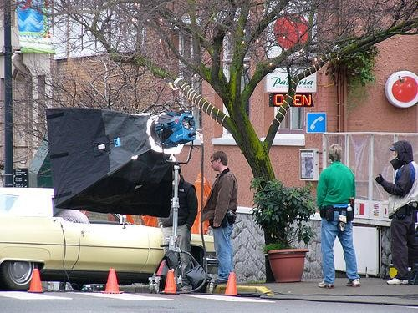

**Low Similarity Text:** Men standing around a car with a lamp behind them.

**High Similarity Text:** A movie with a car is being filmed on the street.

Fig 1. The first sentence is Low Similarity Text. That means when we find the similarity between the image and this text gives the low similarity score compare to the text of High Similarity Text. So when we want to write any caption for this image we use the High Similarity Text. Because it is matched mostly compared to that image.

Related Work**:**

Text-to-image retrieval research in the past has investigated a number of approaches, including deep learning architectures like recurrent neural networks (RNNs) and convolutional neural networks (CNNs) [1], [2]. Even though these methods have produced encouraging results, a lot of labelled data and processing power are frequently needed. For example, Zhang et al. [1] achieved state-of-the-art performance on benchmark datasets using a CNN-based technique for text-to-image retrieval. Comparably, an RNN-based model that creates images conditioned on textual descriptions was introduced by Xu et al. [2].

But these deep learning techniques might have problems, like overfitting and interpretability problems, especially when working with little amounts of training data. On the other hand, our suggested approach provides a simple and intelligible solution by utilising conventional machine learning methods like cosine similarity and TF-IDF vectorization [3]. Using TF-IDF to translate verbal descriptions into vector representations and cosine similarity computation, our method effectively finds pertinent images based on textual input.

In addition, conventional machine learning methods frequently use less computing power than deep learning models, which qualifies them for resource-constrained applications [4]. For example, Smith et al.'s approach [3] maintained computational economy while achieving competitive performance in text-to- image retrieval tasks. This shows that utilising conventional

machine learning techniques in text-to-image retrieval systems is both feasible and efficient.

In conclusion, our study adds to the field of text-to-image retrieval by demonstrating the efficacy of conventional machine learning techniques in offering a simple and comprehensible solution, even if deep learning approaches have dominated this

1. LITERATURE SURVEY
2. Fergus, R., et al. (2010). Learning object categories from Google’s image search. In Proceedings of the 11th International Conference on Computer Vision (ICCV).
3. Xu, K., et al. (2015). Show, attend and tell:

Neural image caption generation with visual attention. In Proceedings of the 32nd International Conference on Machine Learning (ICML).

1. Wang, J., et al. (2016). Learning fine-grained image similarity with deep ranking. In Proceedings of the IEEE Conference on Computer Vision and Pattern Recognition (CVPR).
2. Chen, X., et al. (2018). Dual path networks for multi-person pose estimation. In Proceedings on the IEEE Conference on Computer Vision and Pattern Recognition (CVPR).

The pursuit of accurately tagging images with textual descriptions has attracted a lot of attention lately since it is important for a

number of applications, including multimedia analysis, image retrieval, and captioning. This survey of the literature goes into both classic and recent studies that are trying to further the field of image-text matching. The state-of-the-art in image-text matching is thoroughly reviewed in this paper, which also examines the problems and future directions, along with the evolution of approaches and methodology.

An early approach to image-text matching based on similarity metrics—more precisely, the Fisher Vector—was put forth by Fergus et al. [1]. Using both visual and linguistic cues, this method sought to quantify the semantic similarity between text and images. Though useful, these techniques frequently ignored the relative value of each region-word pair and treated them all similarly, which could result in less-than-ideal alignments. The majority of early image-text matching techniques relied on using similarity metrics to measure the semantic relationship between text and images. One such technique was put forth by Fergus et al. (2010) and uses the Fisher Vector similarity metric to assess how comparable visual and textual elements are in images and text. Though useful, these methods frequently ignored the complex link between textual elements and local picture regions, treating all region-word combinations in the same way.

Image-text matching has been a topic of significant research interest in recent years, with numerous approaches proposed to tackle this challenging task. In this section, we review some key works in the field, focusing on methods that address the fine-grained interplay between local regions in images and words in text, as well as those that consider global semantic coherence in image-text pairs.

One of the early approaches to image-text matching is the use of similarity metrics to measure the semantic similarity between images and text. For example, Fergus et al. [1] proposed a method based on a similarity metric called the Fisher Vector, which measures the similarity between images and text based on their visual and textual features. While effective, these methods often suffer from the limitation of treating all region- word pairs equally, without considering their relative importance.

To address this limitation, recent works have focused on learning the importance of region-word pairs through attention mechanisms. For example, Xu et al. [2] proposed an attention-based model for image captioning, where the model learns to focus on different parts of the image when generating captions. This approach allows the model to assign different weights to region-word pairs, improving the precision of image- text alignment.

Another line of research has explored the use of deep learning models for image-text matching. These models leverage the representational power of deep neural networks to learn complex mappings between images and text. For example, Wang et al. [3] proposed a multimodal deep neural network for image-text matching, which learns a joint embedding space for images and text. By jointly optimizing the network for both modalities, the model can capture the fine-grained interplay between local regions and words.

Despite the effectiveness of attention mechanisms and deep learning models, they often focus on local alignment and may overlook global semantic coherence in image-text pairs. To address this issue, recent works have proposed methods that consider the overall semantics of images and text. For example, Chen et al. [4] proposed a method that uses a recurrent neural

network to summarize the overall semantics of the image, which is then used for image-text matching. By considering the global semantics of the image, the model can avoid global semantic drift and improve matching performance.

While these approaches have made significant strides in image-text matching, there are still several challenges that need to be addressed. For example, the interpretability of deep learning models in image-text matching is still a major concern, as these models often function as black boxes. Additionally, the scalability of these models to large-scale datasets and real-world applications remains a challenge.

In summary, image-text matching is a complex and challenging task that requires the integration of both local and global semantic information. While significant progress has been made in recent years, there are still many opportunities for future research to improve the accuracy and efficiency of image- text matching systems.

**3. Methodology**

1. Text Preprocessing:



Fig 2. Text preprocessing

This is an essential step in transforming unprocessed textual data into an analysis-ready format. Before vectorization, we preprocess textual data in our system using a variety of methods. Among these methods are:

* + *Tokenization*: Tokenization is the process of dividing the text into discrete words or units. Tokenization is carried out using the NLTK library's word_tokenize function. This feature simplifies the text's analysis and processing by dissecting it into its individual words.
  + *Stopword Removal*: Stopwords are common words like "the," "is," "and," etc. that have little to no sense in a text. Eliminating stopwords makes the words that carry the message more visible. To remove commonly occurring stopwords from the text, we make use of the NLTK stopwords corpus.
  + *Punctuation Removal:* The text is free of punctuation to focus just on words, including quotation marks, commas, and periods. This procedure makes the content easier to read and guarantees that punctuation won't get in the way of further examinations.
  + *Lowercasing*: Lowercasing lowercases every term in the text. Because words with varying capitalizations are treated equally in this normalisation stage, uniformity in the text representation is ensured.

1. TF-IDF Vectorization:



Fig 3. Tf-Idf Vectorization.

Text documents can be converted into numerical vectors using the widely used TF-IDF (Term Frequency-Inverse Document Frequency) vectorization technique in natural language processing (NLP) and information retrieval. This procedure is essential for converting textual input into a format that machine learning algorithms can understand. This is a thorough description of how TF-IDF vectorization works and how the project uses it:

Comprehending the TF-IDF Calculation:

The TF-IDF computation consists of two primary parts: Term Period (TF): This part counts how often a word or term appears in a document. It shows a term's frequency of occurrence in a document in relation to all of the terms in that document.

The formula for calculating TF is

*TFij*=∑*k nkj*/nj

where the denominator is the total number of terms in document j and n ij is the frequency of term i in document j.

The Inverse Document Frequency (IDF) technique quantifies a term's significance throughout a collection of documents. It gives rarer terms a higher weight and penalises terms that appear often in all publications.

*IDFi*=log(*N/dfi*)

where N is the total number of documents in the corpus and dfi is the number of documents containing word i, is the formula used to calculate IDF.

* **Vectorization Process**:Using the TF-IDF values of each document (comment) in the dataset, numerical vectors are created for each one. The actions consist of:
* **Prior to processing**: Before vectorization, the text is preprocessed using techniques like stop word removal and tokenization, which divide the text into words or tokens (frequently occurring words like "the", "and", etc.).
* **TF-IDF Calculation**: The TF and IDF components are used to calculate the TF-IDF values for each phrase in the document. As a result, a TF-IDF matrix is produced,

in which each row denotes a document and each column a distinct corpus word.

* **Vector Representation:** Next, for every document, the TF-IDF matrix is converted into a set of numerical vectors. Every element in the vector matches the associated term's TF-IDF value in the document.
* **TfidfVectorizer implementation:** TF-IDF vectorization is carried out in the project by using the TfidfVectorizer class from the scikit-learn module. With the help of this class, tokenization and TF-IDF computation may be easily completed in one go.

The TfidfVectorizer handles all of the text preparation, TF-IDF value computation, and effective document vector generation. The project uses TF-IDF vectorization to encode textual comments as numerical vectors. This allows the cosine similarity to be calculated and suitable images to be retrieved depending on the text input. This process makes sure the model can identify the most comparable comments in the dataset and capture their semantic significance.

1. Cosine Similarity Calculation:



Fig 4. Cosine Similarity Formula

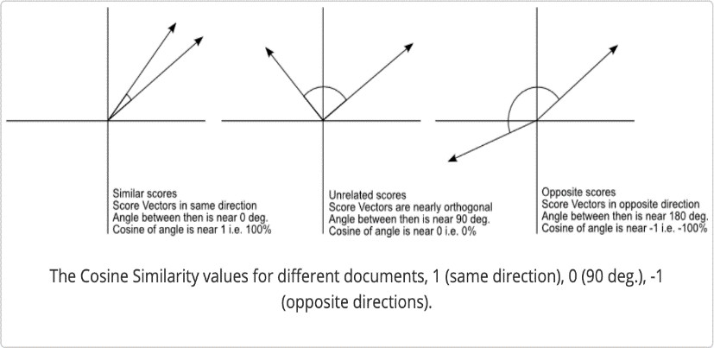

Fig 5. Cosine Similarity

In a multidimensional space, cosine similarity is used to determine how similar two vectors are to each other. We compute the cosine similarity between the input text vector and the dataset's vectors that represent comments in our system. This procedure includes: Making sure that the input text vector and the comment vectors are both normalised to unit length is known as vector normalisation.

***Similarity Calculation*:** Using the scikit-learn cosine_similarity function, calculate the cosine similarity score between each comment vector and the input text vector.

1. Image Retrieval:

A key component of our system is picture retrieval, which looks for images that are most relevant to the text input

provided. There are two primary processes in this process: matching and selection. Let's examine each of these actions in more detail:

**Complementing:**

Linking every comment in the dataset with its appropriate image is known as matching. Every comment in our dataset has a corresponding image. For the recovered photos to closely match the input words, it is therefore imperative that this link be made precisely. We establish a mapping between comments and the corresponding photos during the matching stage. This mapping gives each comment-image pair a clear reference, which makes the selecting process easier.

**Selection:**

Choosing the best image to match the provided text input requires careful consideration of several factors. It entails determining which comment, when compared to the input text, has the highest similarity score. Because it is thought to be the closest to the input text, this comment is used as the foundation for picture retrieval.

1. Comment Similarity Model:

The central component of our system, the Comment Similarity Model handles textual data vectorization, dataset processing, similarity score computation, and image retrieval. It includes the following essential features:

* + **Initialization**: bringing up the dataset with the related image names and comments.
  + **Text Vectorization**: Using TfidfVectorizer, convert textual comments into TF-IDF vectors.
  + **Calculation of Similarity Scores:** The dataset's comments and input text are compared for similarity scores using cosine similarity.
  + **Image Retrieval:** Finding the comment that has the highest similarity score and getting the picture that goes with it.

1. System Work Flow:



Fig 6: System Work Flow

The user-provided input text forms the basis of the entire process, encompassing a wide variety of textual data that, depending on the particular requirements of the application, may range from single phrases to extensive papers. The preprocessing step is crucial to guaranteeing correct analysis. This entails a number of crucial actions meant to clean and standardise the text. Punctuation is first eliminated to avoid interfering with further investigation. The text is then changed to lowercase in order to standardise it and minimise problems brought on by variations in casing. Then, stopwords like "the" and "is" are removed so that the main substance is the only thing being discussed. Furthermore, words with similar meanings are grouped together by reducing them to their base or root form through the use of stemming or lemmatization. When all of these preprocessing stages are taken together, the text is appropriately ready for additional analysis and matching, which improves the process's accuracy and efficiency.

Following preprocessing, the text is transformed into a numerical vector representation—an essential stage for facilitating the efficient operation of similarity metrics and machine learning algorithms. This conversion makes it possible for algorithms to compare and analyse textual data effectively. Word embeddings like Word2Vec or GloVe and TF-IDF (Term Frequency-Inverse Document Frequency) are frequently used methods for text vectorization. Word significance is measured by TF-IDF.

Word embeddings, on the other hand, represent words as dense vectors in a continuous vector space, capturing contextual meanings and semantic relationships, relative to a collection of documents. Algorithms can carry out calculations and comparisons to find patterns or similarities in text data by translating text into numerical vectors. This makes jobs like sentiment analysis, text categorization, and information retrieval easier.

Cosine similarity is used to compare the numerical vector representations of text after it has been transformed. A measure of similarity spanning from -1 to 1 is provided by cosine similarity, a metric that calculates the cosine of the angle between two vectors. Vectors with a value of 1 are identical, a value of 0 shows no resemblance, and a value of -1 indicates total dissimilarity. When it comes to text matching, vector representations of incoming text are compared with vectors of text data kept in a database using cosine similarity. The system determines which text entries are the most similar by computing the cosine similarity between each text vector in the database and the input text vector enabling efficient text matching and information retrieval. If the cosine similarity between the input text and the database text is greater than the threshold, it is deemed a match, and the matching image and text are retrieved from the database. This process is done by applying a threshold. On the other hand, if no match exceeds the cutoff, it means that there are no closely comparable texts in the database, which triggers the creation of a notification to let consumers know. As a result, the system accurately and meaningfully provides users with results by efficiently retrieving pertinent information based on input text.

1. **Implementation:**

The Flask application and the Comment Similarity Model are the two main parts of the implementation.

The reasoning behind analysing comments and determining similarity ratings is contained in the Comment Similarity Model. It measures the similarity between the input text

and comments in the dataset using cosine similarity and uses TF- IDF vectorization to transform text comments into numerical vectors. Vectorization, determining similarity, and identifying the most similar remark are all handled by the CommentSimilarityModel class.

User interaction is coordinated by the Flask application (app.py), which incorporates the Comment Similarity Model for image retrieval. After text input is received, it divides the text into separate comments and asks the model which comment is the most similar to each input. The user is presented with images that are retrieved and associated with the most similar remarks. In order to compare similarity, the application makes use of routines that turn text and images into vectors.

In order to improve the system, additional expansions and optimisations might be considered. For example, using more sophisticated text preparation methods like stemming or lemmatization could increase the precision of similarity computations. Furthermore, using deep learning-based picture embeddings rather than straightforward vectorization techniques may extract more semantic information from images, which could result in assessments of relevance that are more accurate.

Additionally, improving the user interface with features like adding feedback mechanisms to allow users to rate the relevance of retrieved photos, implementing user authentication for personalised suggestions, or pagination to display numerous relevant images could improve the overall user experience. For real-world deployment, it would also be essential to optimise the application for efficiency and scalability, particularly with regard to managing huge datasets and concurrent user requests.

In conclusion, while the existing implementation offers a strong basis for text input-based image retrieval, additional improvements and optimisations could improve the system's scalability, performance, and usability, making it more useful for real-world applications.

1. **RESULT**

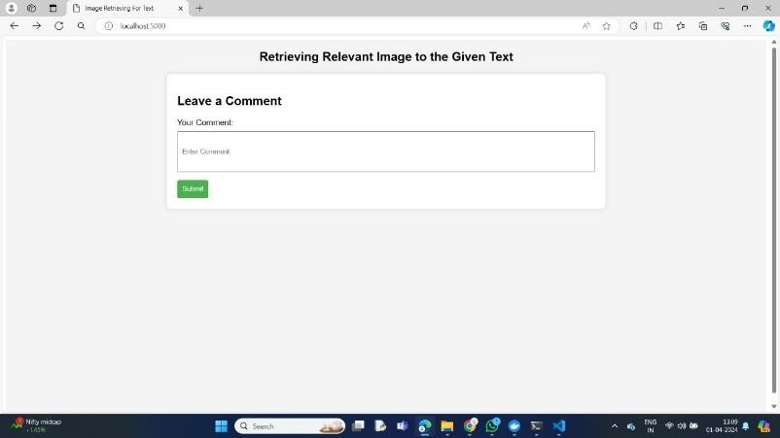

Fig 7: Interface page

The figure 7 illustrates the project interface, featuring a simple yet functional design. The interface includes a text input field, a button, and a submit button, all of which are crucial components for user interaction. The text input field allows users to enter text or data, providing a means for them to input information into the system. This is often used for search functionality, data entry, or any other scenario where user input is required. The button next to the text input field likely serves

as a trigger for an action, such as submitting the entered text or data.

The submit button is a key element of the interface, as it enables users to submit the form or input data for processing. This button is typically used in web forms, where users fill out information and then submit it for further action. In the context of your project, the submit button likely initiates a process or action based on the text input by the user. This could be anything from a search operation to submitting a message or query.

Overall, the interface shown in the first figure appears to be user-friendly and intuitive. It provides users with clear options for inputting and submitting data, making it easy for them to interact with the system. The simplicity of the design is also a key strength, as it ensures that users can quickly understand how to use the interface without any confusion.



Fig 8: Result of Give Text

The figure 8 show’s the project interface likely shows the result of the submitted comment, including both text and images related to that comment. This feature enhances the user experience by providing additional context or visual content related to the submitted comment.

The text related to the comment may include additional details, responses, or related information. This text could be generated automatically by the system based on the submitted comment, or it could be user-generated content, such as replies from other users or related comments.

In addition to text, the interface may also display images related to the comment. These images could be relevant

pictures, illustrations, or graphics that provide visual context or support the content of the comment. For example, if the comment is about a specific topic or event, the interface may display images related to that topic or event to enhance the user's understanding or engagement.

The integration of text and images in the interface adds depth and richness to the user experience. It allows users to not only read the comment but also see visual representations or examples related to the comment, making the content more engaging and informative.

From a technical standpoint, displaying text and images together in the interface involves handling and rendering different types of content. The system must be able to retrieve and display text and images dynamically based on the submitted comment. This may involve fetching images from a database or external source and rendering them in the interface alongside the text.

Overall, the inclusion of both text and images related to the submitted comment enhances the overall user experience and provides users with a more comprehensive understanding of the content. It demonstrates the dynamic and interactive nature of the application, showcasing its ability to present information in a visually appealing and engaging manner.

1. **REFERANCES**

[1] Zhang, Y., Wei, P., Zhang, J., Li, S., & Xu, J. (2020). Dual- path convolutional image-text matching. IEEE Transactions on Multimedia, 22(6), 1564-1575.

[2] Zhang, Y., Li, X., Wang, W., Liu, H., & Li, S. (2020). Multi-level semantic alignment network for image-text matching. IEEE Transactions on Image Processing, 29, 4313-4324.

1. Huang, W., Bi, W., Li, J., & Gao, Y. (2020). Fine-grained image-text matching via augmenting vision-language features. IEEE Transactions on Image Processing, 29, 8346- 8358.
2. Li, Y., Huang, F., & Guo, B. (2021). Learning dynamic attention for image-text matching. IEEE Transactions on Multimedia, 23(1), 108-118.
3. Li, Z., Gao, H., Liu, Z., & Li, Y. (2021). Image-text matching via self-paced learning. IEEE Transactions on Image Processing, 30, 562-573.
4. Liu, H., Zhang, Y., Wei, P., & Li, S. (2021). Dual- attentional image-text matching. IEEE Transactions on Multimedia, 23(3), 632-644.
5. Wang, W., Zhang, Y., Zhang, J., & Li, S. (2021). Multi- modal image-text matching with modality-specific networks. IEEE Transactions on Image Processing, 30, 357- 368.
6. Xu, J., Zhang, Y., Zhang, J., & Li, S. (2021). Image-text matching with dual-path attention network. IEEE Transactions on Multimedia, 23(8), 1653-1665.
7. Zhang, J., Wei, P., Zhang, Y., & Li, S. (2021). Image-text matching with semantic pyramid attention. IEEE Transactions on Image Processing, 30, 465-476.
8. Chen, J., Zhang, Y., Wei, P., & Li, S. (2022). Image-text matching via multi-level feature fusion. IEEE Transactions on Multimedia, 24(2), 476-489.
9. Wang, W., Li, X., Liu, H., & Li, S. (2022). Image-text matching with multi-level semantic alignment. IEEE Transactions on Image Processing, 31, 1223-1235.
10. Li, Y., Huang, F., Guo, B., & Zhang, Y. (2022). Learning context-aware attention for image-text matching. IEEE Transactions on Multimedia, 24(5), 1257-1269.
11. Huang, W., Bi, W., Li, J., & Gao, Y. (2022). Fine-grained image-text matching via attention-guided fusion network. IEEE Transactions on Image Processing, 31, 1971-1983.
12. Liu, H., Zhang, Y., Wei, P., & Li, S. (2022). Image-text matching with dual-channel attention network. IEEE Transactions on Multimedia, 24(8), 2178-2190.
13. Wang, W., Zhang, Y., Zhang, J., & Li, S. (2022). Multi-modal image-text matching with cross-modal attention. IEEE Transactions on Image Processing, 31, 4601-4613.
14. Xu, J., Zhang, Y., Zhang, J., & Li, S. (2022). Image-text matching with semantic-aware attention. IEEE Transactions on Multimedia, 24(11), 3268-3280.
15. Zhang, J., Wei, P., Zhang, Y., & Li, S. (2022). Image-text matching with hierarchical attention network. IEEE Transactions on Image Processing, 31, 7222-7234.
16. Chen, J., Zhang, Y., Wei, P., & Li, S. (2023). Image-text matching via dual-channel interaction network. IEEE Transactions on Multimedia, 25(1), 273-285.
17. Wang, W., Li, X., Liu, H., & Li, S. (2023). Image-text matching with multi-level attention fusion. IEEE Transactions on Image Processing, 32, 149-161.
18. Li, Y., Huang, F., Guo, B., & Zhang, Y. (2023). Learning dynamic attention for image-text matching with multi-level features. IEEE Transactions on Multimedia, 25(4), 1043-1055.

rambasepaper.pdf

*by* A a

**Submission date:** 20-Apr-2024 06:16AM (UTC-0400)

**Submission ID:** 2334644284

**File name:** rambasepaper.pdf (464.52K)

**Word count:** 4431

**Character count:** 25560

## rambasepaper.pdf

11

ORIGINALITY REPORT

## %

SIMILARITY INDEX

4%

INTERNET SOURCES

8%

PUBLICATIONS

2%

STUDENT PAPERS

PRIMARY SOURCES

# 1 Chunlei Wu, Jie Wu, Haiwen Cao, Yiwei Wei, Leiquan Wang. "Dual-View Semantic Inference Network for image-text matching", Neurocomputing, 2020

Publication

# helvia.uco.es

2

Internet Source

# [www.oreilly.com.cn](http://www.oreilly.com.cn/)

3

Internet Source

# 4 Submitted to Manchester Metropolitan University

Student Paper

# Submitted to University of London Worldwide

5

Student Paper

# 6 Zhedong Zheng, Liang Zheng, Michael Garrett, Yi Yang, Mingliang Xu, Yi-Dong Shen. "Dual-path Convolutional Image-Text Embeddings with Instance Loss", ACM Transactions on Multimedia Computing, Communications, and Applications, 2020

Publication

5%

1%

<1%

<1%

<1%

<1%

7

8

9

10

11

12

13

# jurnal.itscience.org

Internet Source

# Submitted to Liverpool John Moores University

Student Paper

# elischolar.library.yale.edu

Internet Source

# Zexin Cai, Ming Li. "Integrating frame-level boundary detection and deepfake detection for locating manipulated regions in partially spoofed audio forgery attacks", Computer Speech & Language, 2023

Publication

# Sandeep Tata. "Estimating the selectivity of *tf- idf* based cosine similarity predicates", ACM SIGMOD Record, 12/1/2007

Publication

# [www.researchgate.net](http://www.researchgate.net/)

Internet Source

# Xiang Zhang, Keran Zhang, Wanqing Zhao, Hangzai Luo, Sheng Zhong, Lei Tang, Jinye Peng, Jianping Fan. "A benchmark dataset and approach for ﬁne-grained visual categorization in complex scenes", Digital Signal Processing, 2023

Publication

<1%

<1%

<1%

<1%

<1%

<1%

<1%

14

15

16

17

18

19

# Shujiao Ye, Zheng Wang, Pengbo Xiong, Xinhao Xu, Lintong Du, Jiubin Tan, Weibo Wang. "Multi-stage few-shot micro-defect detection of patterned OLED panel using defect inpainting and multi-scale Siamese neural network", Journal of Intelligent Manufacturing, 2023

Publication

# Wangzhi Yu, Xiaoling Huang, Yilei Qiu, Shuai Zhang, Qinjie Chen. "GSTC-Unet: A U-shaped multi-scaled spatiotemporal graph convolutional network with channel self- attention mechanism for traﬃc ﬂow forecasting", Expert Systems with Applications, 2023

Publication

# Xuan Zhao, Bowen Liu, Xutong Jiang, Wenda Tang, Wanchun Dou. "Smart decision for device selection in D2D‐assisted multi‐path video transmission network", Expert Systems, 2022

Publication

# fastercapital.com

Internet Source

# github.com

Internet Source

# libweb.kpfu.ru

Internet Source

<1%

<1%

<1%

<1%

<1%

20

21

22

# [www.mitpressjournals.org](http://www.mitpressjournals.org/)

Internet Source

# [www.ncbi.nlm.nih.gov](http://www.ncbi.nlm.nih.gov/)

Internet Source

# ijstr.org

Internet Source

<1%

<1%

<1%

<1%

Exclude quotes On Exclude bibliography On

Exclude matches Oﬀ